

DATA STRUCTURES & ALGORITHMS
23CSE203
LAB MANUAL
Submitted By
Name | Pardhiv Sai B
Roll No. | AV.SC.U4CSE25022
Year/Sem/Section | 2nd year /Sem-3/CSE-A
Credits | 05

Submitted To
Professor Name: | Dr. RajKumar Batchu
Designation | Asst.Professor(S.I. GRADE)

INDEX
DATA STRUCTURES LAB – INDEX
Week | Date | Experiment / Program Name | Page No.
Week 1 | 23-07-26 | Recursion | 5–16
1A |  | Recursive countdown from n to 1, followed by "Launch"
1B |  | Recursive calculation of \(P^n\) (power)
1C |  | Recursive search for an employee ID in a list
1D |  | Recursive calculation of factorial
1E |  | Recursive printing of the first n Fibonacci terms
Week 2 | 30-07-26 | Searching | 17–18
2A |  | Linear Search
2B |  | Binary Search (sorted and unsorted arrays)
Week 3 | 06-08-26 | Sorting | 19–28
3A |  | Selection Sort
3B |  | Insertion Sort
3C |  | Bubble Sort
3D |  | Merge Sort
3E |  | Quick Sort
Week 4 | 13-08-26 | Linked Lists | 29–49
4A |  | Singly Linked List
4B |  | Doubly Linked List
4C |  | Circular Linked List
Week 5 | 27-08-26 | Stack | 50–56
5A |  | Stack Implementation Using Array and Linked List (Push, Pop, Peek, Display)
Week 6 | 03-09-26 | Queue | 57–71
6A |  | Queue Implementation Using Array, Linked List and Circular Queue
6B |  | Circular Queue Implementation Using Array and Linked List
Week 7 | 24-09-26 | Binary Search Tree (BST) | 72–85
7A |  | Binary Search Tree Implementation Using Array and Linked List with All Operations
Week 8 | 08-10-26 | Binary Tree | 86–91
8A |  | Binary Tree Implementation Using Array and Linked List with Operations
Week 9 | 22-10-26 | AVL Tree | 92–124
9A |  | AVL Tree Implementation Using Array and Linked List with All Operations
Week 10 | 29-10-26 | Hashing
10A |  | Hashing Implementation Using Separate Chaining, Linear Probing and Quadratic Probing

WEEK-1

1A) Aim: Rocket launch systems display the countdown of before launch instead of using a loop implement the countdown using the recursion write a recursion Python program to display the countdown from n to 1 followed by launch.

Program:
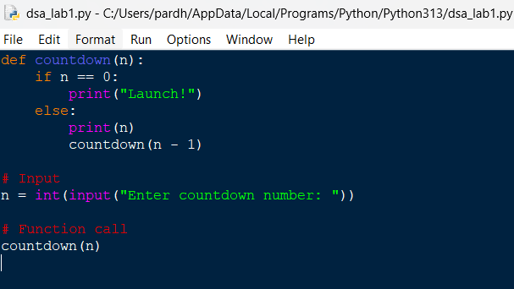
Output:
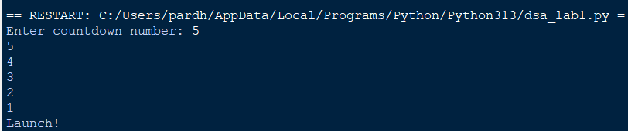

Explanation:
- def defines the countdown() function.
- input() accepts the countdown value from the user.
- int() converts the input into an integer.
- countdown() starts the recursive countdown process.
- if checks the base case (n == 0).
- else executes when the condition is False.
- print(n) displays the current countdown number.
- countdown(n - 1) recursively calls the function with the value decreased by 1.
- print("Launch!") displays the launch message when the countdown reaches 0.
- The program demonstrates the use of functions, recursion, conditional statements, input, and output to perform the countdown.
Error Table:
S.No. | Errors Observed | Rectification
1) | Invalid (non-numeric) input entered by the user. | Enter a valid integer as input.
2) | Missing base case (if n == 0) causing infinite recursion. | Include the base case to stop recursion .l
3) | incorrect indentation leading to an Indentation Error | Maintain proper Python indentation.
4) | Missing colon (:) after def, if, or else. | Add the required colon (:) after statements.
5) | Calling countdown(n) instead of countdown (n - 1), causing infinite recursion. | Decrease the value by 1 in each recursive call using countdown (n - 1).

1B) Aim: Banks calculate the growth of an investment using compound interest. The formula requires calculating powers, which can be implemented recursively. Write a recursive Python program to calculate P^n (power), where P = Principal growth factor, n = number of years.

Program:
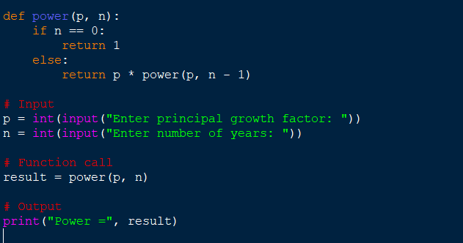
Output:
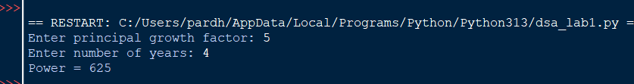

Explanation:
- power() is the recursive function that computes P raised to n.
- The base case is n == 0, which returns 1 (any number to the power 0 is 1).
- The recursive case multiplies p with power(p, n - 1), reducing n by 1 on each call.
- float() allows the principal growth factor to be a decimal value.
- input() collects the values of P and n from the user.
- Each recursive call is stacked until the base case is reached, then the results are multiplied back up the call stack.
- print() displays the final computed value of P^n.
Error Table:
S.No. | Errors Observed | Rectification
1) | Missing base case (n == 0) causing infinite recursion. | Include the base case to stop recursion.
2) | Entering a negative value for n causes the recursion to never reach 0. | Restrict input to non-negative integers or handle negative n separately.
3) | Using int() for P truncates decimal growth factors. | Use float() to accept decimal values for P.
4) | Incorrect indentation leading to an IndentationError. | Maintain proper Python indentation.
5) | Calling power(p, n) instead of power(p, n - 1), causing infinite recursion. | Decrease n by 1 in each recursive call using power(p, n - 1).

1C) Aim: An HR department stores employee IDs in a list. Develop a recursive program to search for a given employee ID. Write a recursive function to search for an employee ID in a list.
Program:
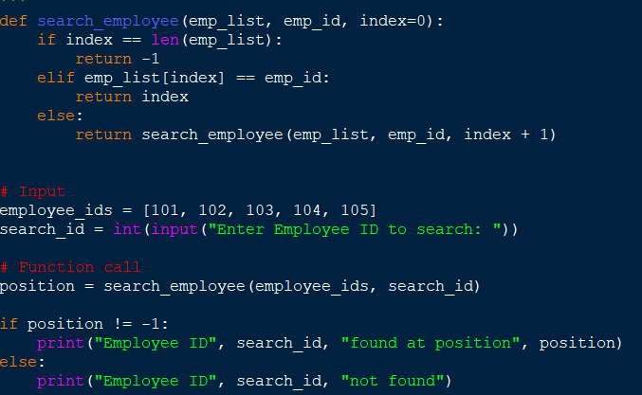
Output:

Explanation:
- search_employee() is the recursive function that searches the list one index at a time.
- The base case index == len(emp_list) means every element was checked and the ID was not found, so it returns -1.
- The second condition checks if the current element matches the employee ID being searched.
- If not matched, the function calls itself with index + 1, moving to the next employee in the list.
- employee_ids is the list of employee IDs stored by the HR department.
- input() and int() collect the employee ID to search for from the user.
- The if-else block reports whether the employee ID was found and at which position.
Error Table:
S.No. | Errors Observed | Rectification
1) | Missing base case (index == len(emp_list)) causing infinite recursion. | Include the base case to stop recursion when the list is exhausted.
2) | Invalid (non-numeric) input entered by the user. | Enter a valid integer as input.
3) | Calling search_employee(emp_list, emp_id, index) without incrementing index, causing infinite recursion. | Increase index by 1 in each recursive call using index + 1.
4) | Incorrect indentation leading to an IndentationError. | Maintain proper Python indentation.
5) | Searching an empty list without handling it, giving a confusing result. | Add a check for an empty list before searching.

1D) Aim:In a logistics company, the number of possible ways to arrange n different parcels is calculated using the factorial formula. Develop a recursive program to calculate the factorial of a given number.
Program:
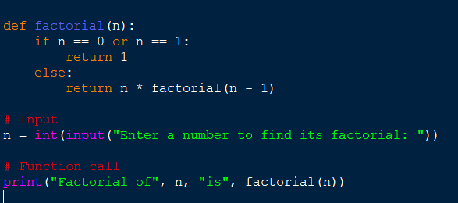
Output:

Explanation:
- factorial() is the recursive function that computes n! (n factorial).
- The base case is n == 0 or n == 1, both of which return 1.
- The recursive case multiplies n with factorial(n - 1), reducing n by 1 on each call.
- input() and int() collect the number whose factorial is to be found.
- Each recursive call is stacked until the base case is reached, then the results are multiplied back up the call stack.
- print() displays the number of possible arrangements (the factorial value).
Error Table:
S.No. | Errors Observed | Rectification
1) | Missing base case (n == 0 or n == 1) causing infinite recursion. | Include the base case to stop recursion.
2) | Entering a negative number, for which factorial is undefined. | Restrict input to non-negative integers.
3) | Invalid (non-numeric) input entered by the user. | Enter a valid integer as input.
4) | Incorrect indentation leading to an IndentationError. | Maintain proper Python indentation.
5) | Calling factorial(n) instead of factorial(n - 1), causing infinite recursion. | Decrease n by 1 in each recursive call using factorial(n - 1).

1E) Aim:Write a recursive Python program to print the first n terms of a Fibonacci series.

Program:
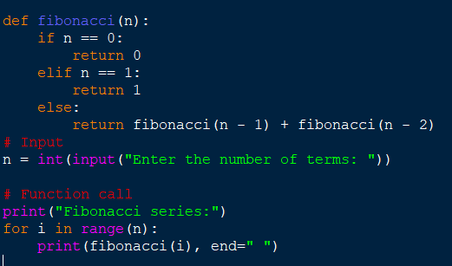

Output:
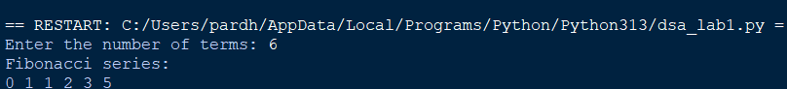

Explanation:
- fibonacci() is the recursive function that returns the nth Fibonacci term.
- The base cases are n == 0 (returns 0) and n == 1 (returns 1).
- The recursive case adds fibonacci(n - 1) and fibonacci(n - 2), following the Fibonacci rule.
- input() and int() collect the number of terms to be printed.
- The for loop calls fibonacci(i) for each index from 0 to n - 1.
- print(..., end=" ") displays each term on the same line, separated by a space.
Error Table:
S.No. | Errors Observed | Rectification
1) | Missing base cases (n == 0 and n == 1) causing infinite recursion. | Include both base cases to stop recursion.
2) | Entering a negative number of terms. | Restrict input to non-negative integers.
3) | Invalid (non-numeric) input entered by the user. | Enter a valid integer as input.
4) | Incorrect indentation leading to an IndentationError. | Maintain proper Python indentation.
5) | Using fibonacci(n - 1) - fibonacci(n - 2) instead of addition, giving wrong terms. | Use addition, fibonacci(n - 1) + fibonacci(n - 2), as per the Fibonacci rule.

WEEK-2

2A) Aim: Write a python program to perform linear search on the given input.
Program:

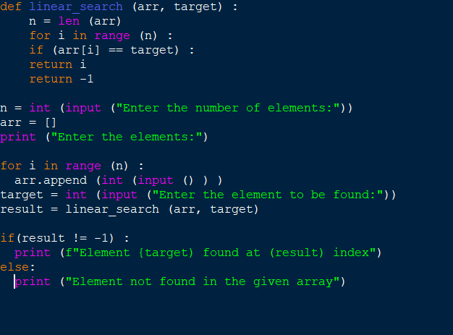
Output:

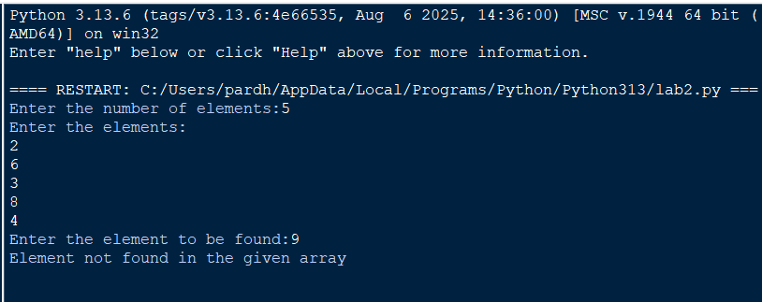

Explanation:
- linear_search(arr, target) sequentially iterates through arr to check each element against target.
- for i in range(n): iterates through array indices from 0 to n-1 sequentially.
- if arr[i] == target: checks for a match and returns index i if found.
- return -1 executes when the target element is absent from the array.
- arr.append(int(input())) converts user input to integers and builds the array.
- if (result != -1): displays the index where the element is found or prints a "not found" message.
Error Table:
S.No. | Errors Observed | Rectification
1) | Invalid (non-numeric) input entered by the user. | Entered a valid integer as input.
2) | Incorrect indentation leading to an Indentation Error | Maintained proper Python indentation.
3) | Missing colon (:) after def, for, if, or else. | Added the required colon (:) after statements.
4) | ValueError when passing non-integer strings to int(input()). | Ensure user input consists of valid integer characters.
5) | IndexError caused by accessing an array index out of bounds. | Ensure loop bounds do not exceed len(arr) - 1.

2B) Aim: Write a python program to perform binary search on the given input.Verify by taking sorted array and unsorted array as input.
Program:
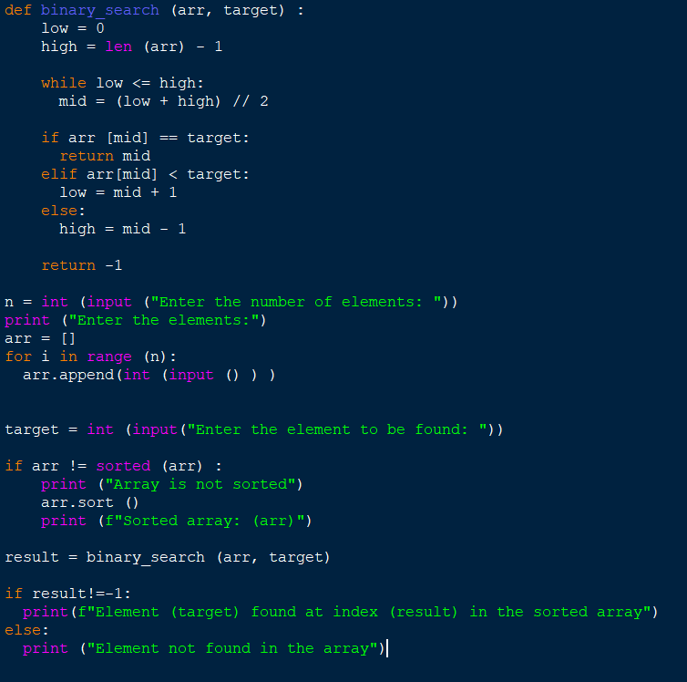
Output:
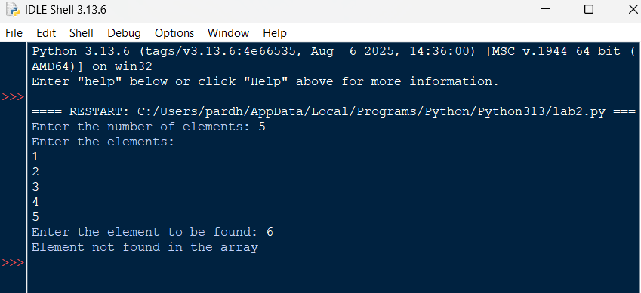
Explanation:
- binary_search(arr, target) uses a divide-and-conquer strategy on a sorted array.
- while low <= high: runs as long as the search boundary contains valid elements.
- mid = (low + high) // 2 computes the middle index using integer division.
- if arr[mid] == target: returns mid if the target is found at the middle index.
- elif arr[mid] < target: updates low = mid + 1, otherwise sets high = mid - 1.
- arr.sort() ensures the input array is sorted before executing binary search.
Error Table:
S.No. | Errors Observed | Rectification
1) | Performing binary search on an unsorted array leading to incorrect results. | Sort the array using arr.sort() before applying binary search.
2) | Using floating-point division / instead of integer division // for calculating mid, causing a TypeError. | Use mid = (low + high) // 2 for integer index calculation.
3) | Incorrect loop condition (low < high instead of low <= high), missing target when low == high. | Change the condition to while low <= high:.
4) | Incorrectly updating pointers like low = mid or high = mid causing an infinite loop. | Use low = mid + 1 and high = mid - 1.
5) | Invalid (non-numeric) input entered by the user. | Enter a valid integer as input.

WEEK-3
3A) Aim: Write a python program to sort an array using selection sort and take the elements as input from user;
Program:
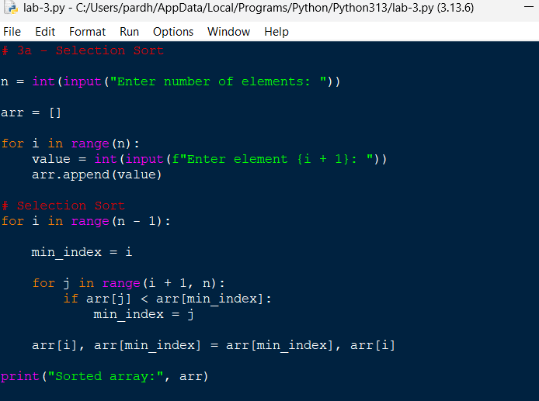
Output:
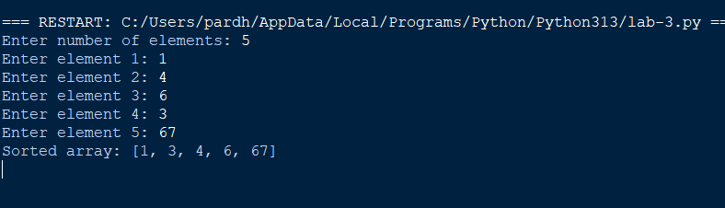

Explanation;
Took the number of elements from the user.
• Created an empty list arr.
• Used a for loop to take each element individually.
• min_index stores the position of the smallest element.
• The inner loop searches for the smallest element in the unsorted portion.
• Swapped the smallest element with the first unsorted element.
• Repeated this until the array was sorted

Error Table:
S.No. | Errors Observed | Rectification
1) | Incorrect initialization of min_index, causing the minimum element to be identified incorrectly. | Initialize min_index = i before searching for the minimum element.
2) | Starting the inner loop from 0, causing already sorted elements to be checked again. | Start the inner loop from i + 1.
3) | Forgetting to update min_index when a smaller element is found. | Use min_index = j inside the if condition.
4) | Incorrect swapping of elements, resulting in an unsorted array. | Use arr[i], arr[min_index] = arr[min_index], arr[i].
5) | Invalid (non-numeric) input entered by the user. | Enter a valid integer for each array element.
6) | Incorrect indentation causing an IndentationError. | Maintain proper indentation inside for loops and if statements.

3B) Aim: Write a python program to sort an array using Insertion sort and take the elements as input from user;
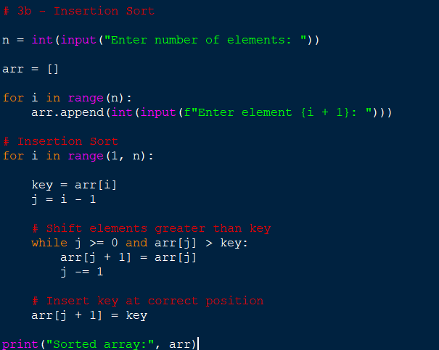
Output:
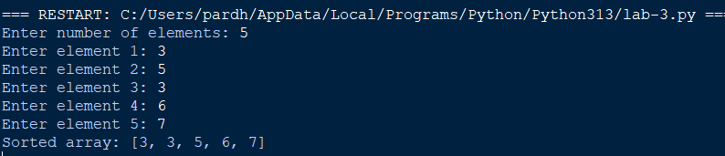

Explanation:
• Took the number of elements from the user.
• Used a loop to input every element.
• Started sorting from index 1.
• Stored the current element in key.
• Compared key with the elements before it.
• Shifted larger elements one position to the right.
• Inserted key into its correct position.
• Repeated until the array was sorted.

Error Table:
S.No. | Errors Observed | Rectification
1) | Starting the outer loop from 0, unnecessarily processing the first element. | Start the loop from 1 because the first element is already considered sorted.
2) | Forgetting to store the current element in key. | Use key = arr[i] before shifting elements.
3) | Forgetting j -= 1, causing the while loop to run indefinitely. | Decrease j by using j -= 1 after shifting an element.
4) | Placing the key at arr[j] instead of arr[j + 1]. | Insert the key using arr[j + 1] = key.
5) | Incorrect condition in the while loop. | Use j >= 0 and arr[j] > key to shift larger elements.

3C) Aim: Write a python program to sort an array using Bubble sort and take the elements as input from user
Program:
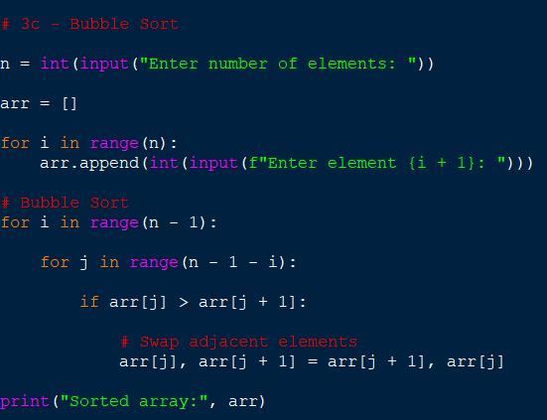
Output:
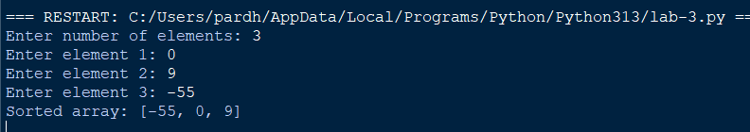

Explanation:
• Took the number of elements.
• Input each element using a loop.
• Compared two adjacent elements.
• If the left element was greater, we swapped them.
• After every pass, the largest remaining element moved to the end.
• Reduced the comparison range after every pass.
• Repeated until the array became sorted.

Error Table:
S.No. | Errors Observed | Rectification
1) | Comparing non-adjacent elements instead of neighboring elements. | Compare arr[j] with arr[j + 1].
2) | Using an incorrect inner loop range. | Use range(n - 1 - i) so that already sorted elements are not checked
3) | Forgetting to swap elements when they are in the wrong order. | Use arr[j], arr[j + 1] = arr[j + 1], arr[j].
4) | Using < instead of > for ascending order. | Use if arr[j] > arr[j + 1] for ascending sorting.
5) | Using an incorrect outer loop range. | Use range(n - 1) to perform the required passes.
6) | Entering non-numeric values as array elements. | Enter valid integer values using int(input()).

3A) Aim: Write a python program to sort an array using Merge sort and take the elements as input from user; 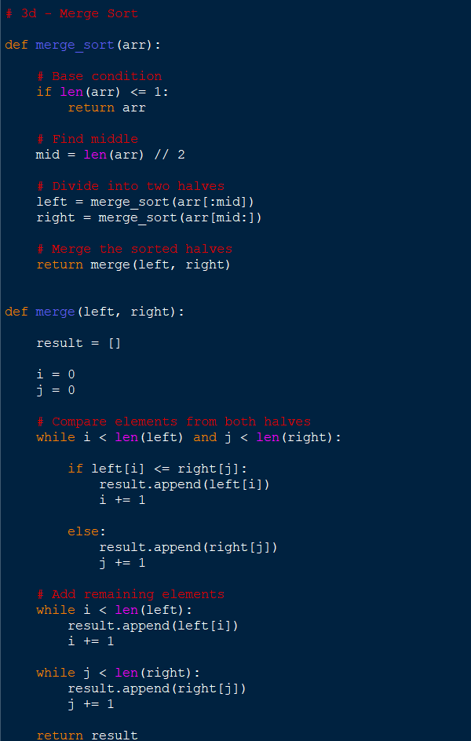

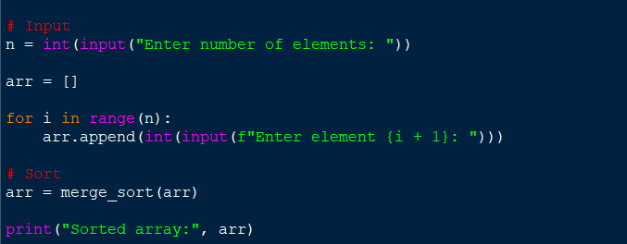

Output:
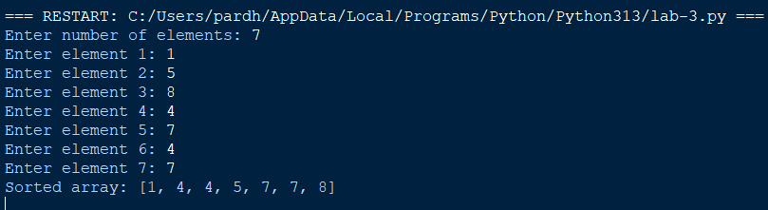

Explanation:
• Took the number of elements from the user.
• Used a loop to input the array.
• Used recursion to divide the array.
• Divided the array into two halves.
• Continued dividing until each part contained one element.
• Used the merge() function to combine the smaller arrays.
• Compared elements from the left and right halves.
• Added the smaller element to result.
• Added remaining elements.
• Returned the sorted array.

S.No. | Errors Observed | Rectification
1) | Missing base case causing infinite recursion. | Include if len(arr) <= 1: return arr to stop recursion.
2) | Incorrect calculation of the middle position. | Use mid = len(arr) // 2 to divide the array correctly.
3) | Incorrectly dividing the array into left and right parts. | Use arr[:mid] for the left half and arr[mid:] for the right half.
4) | Forgetting to increment i or j while merging. | Increment the corresponding index after adding an element to result.
5) | Forgetting to add the remaining elements from either half. | Add the remaining elements using result.extend(left[i:]) and result.extend(right[j:]).
6) | Forgetting to return the merged result. | Use return result at the end of the merge() function.
7) | Incorrect indentation in recursive functions. | Maintain proper indentation for all function statements, loops, and conditions.
3A) Aim: Write a python program to sort an array using Quick sort and take the elements as input from user;
Program:
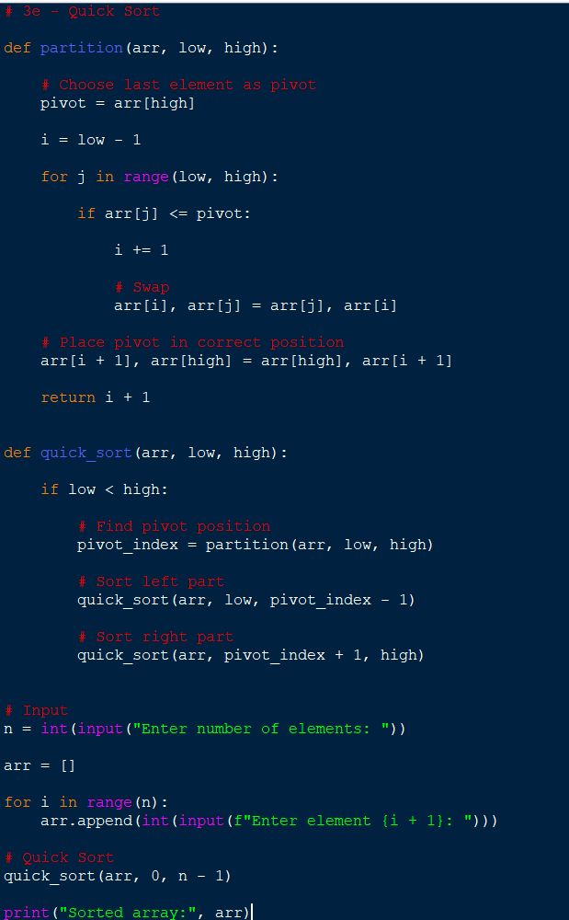
Output:
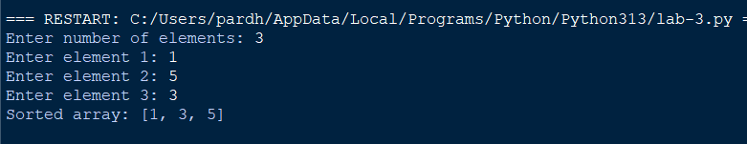

Explanation:
• Took the number of elements.
• Used a loop to input every element.
• Selected the last element as the pivot.
• Compared every element with the pivot.
• Elements smaller than or equal to the pivot were moved to the left.
• Elements greater than the pivot remained on the right.
• Placed the pivot in its correct position.
• Recursively sorted the left and right portions.
• Continued until the entire array was sorted.

S.No. | Errors Observed | Rectification
1) | Missing base condition causing infinite recursion. | Use if low < high: to continue recursion only when elements remain to be sorted.
2) | Incorrectly selecting or accessing the pivot element. | Select the last element using pivot = arr[high].
3) | Forgetting to return the pivot index from the partition function. | Use return i + 1 after placing the pivot.
4) | Incorrect recursive boundaries causing the pivot to be processed again. | Use quick_sort(arr, low, pivot_index - 1) and quick_sort(arr, pivot_index + 1, high).
5) | Incorrect initial function call. | Call quick_sort(arr, 0, n - 1) to sort the complete array.
6) | Incorrect partition condition resulting in improper ordering. | Use if arr[j] <= pivot for ascending order.
7) | Forgetting to swap the pivot into its correct position. | Use arr[i + 1], arr[high] = arr[high], arr[i + 1].
8) | Incorrect indentation causing an IndentationError. | Maintain proper Python indentation inside functions, loops, and conditions.

WEEK-4
Aim: Write a menu-driven Python program to implement a Singly Linked List using classes Node and LinkedList.
The program should support the following operations:
- Create a linked list with n nodes.
- Insert a node at the beginning.
- Insert a node at the end.
- Insert a node at a specific index.
- Delete a node from a specific index.
- Delete the first node.
- Delete the last node.
- Count the number of nodes in the linked list.
- Display/traverse the linked list.
- Exit the program.
Program:
class Node:
def __init__(self, data):
self.data = data
self.next = None

class LinkedList:
def __init__(self):
self.head = None

# 1. Create a linked list
def create(self):
n = int(input("Enter number of nodes: "))

for i in range(n):
data = int(input("Enter value: "))
new_node = Node(data)

if self.head is None:
self.head = new_node
else:
temp = self.head
while temp.next is not None:
temp = temp.next
temp.next = new_node

# 2. Insert at beginning
def insert_beginning(self):
data = int(input("Enter value: "))
new_node = Node(data)

new_node.next = self.head
self.head = new_node

# 3. Insert at end
def insert_end(self):
data = int(input("Enter value: "))
new_node = Node(data)

if self.head is None:
self.head = new_node
return

temp = self.head
while temp.next is not None:
temp = temp.next

temp.next = new_node

# 4. Insert at a specific index
def insert_index(self):
data = int(input("Enter value: "))
index = int(input("Enter index: "))

new_node = Node(data)

if index == 0:
new_node.next = self.head
self.head = new_node
return

temp = self.head
prev = None
count = 0

while temp is not None and count < index:
prev = temp
temp = temp.next
count += 1

if count != index:
print("Invalid index")
return

prev.next = new_node
new_node.next = temp

# 5. Delete at a specific index
def delete_index(self):
index = int(input("Enter index to delete: "))

if self.head is None:
print("List is empty")
return

if index == 0:
self.head = self.head.next
return

temp = self.head
prev = None
count = 0

while temp is not None and count < index:
prev = temp
temp = temp.next
count += 1

if temp is None:
print("Invalid index")
return

prev.next = temp.next

# 6. Delete first node
def delete_first(self):
if self.head is None:
print("List is empty")
return

self.head = self.head.next

# 7. Delete last node
def delete_last(self):
if self.head is None:
print("List is empty")
return

if self.head.next is None:
self.head = None
return

temp = self.head

while temp.next.next is not None:
temp = temp.next

temp.next = None

# 8. Count number of nodes
def count_nodes(self):
count = 0
temp = self.head

while temp is not None:
count += 1
temp = temp.next

print("Number of nodes:", count)

# 9. Display / Traverse
def display(self):
if self.head is None:
print("List is empty")
return

temp = self.head

while temp is not None:
print(temp.data, end=" -> ")
temp = temp.next

print("None")

# Main program
linked_list = LinkedList()

while True:
print("\n----- SINGLY LINKED LIST -----")
print("1. Create a linked list")
print("2. Insert at beginning")
print("3. Insert at end")
print("4. Insert at a specific index")
print("5. Delete at a specific index")
print("6. Delete first node")
print("7. Delete last node")
print("8. Count number of nodes")
print("9. Display / Traverse")
print("10. Exit")

choice = int(input("Enter your choice: "))

if choice == 1:
linked_list.create()

elif choice == 2:
linked_list.insert_beginning()

elif choice == 3:
linked_list.insert_end()

elif choice == 4:
linked_list.insert_index()

elif choice == 5:
linked_list.delete_index()

elif choice == 6:
linked_list.delete_first()

elif choice == 7:
linked_list.delete_last()

elif choice == 8:
linked_list.count_nodes()

elif choice == 9:
linked_list.display()

elif choice == 10:
print("Exiting...")
break

else:
print("Invalid choice")

Output:
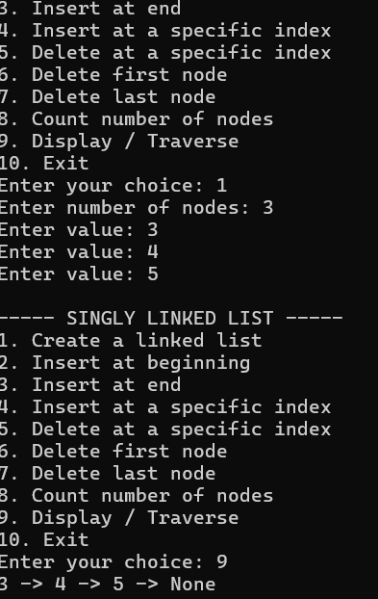
Singly Linked List — Code Explanation
- Node class creates each node with two parts: data and next.
- LinkedList class maintains the linked list using a head pointer.
- create() creates n nodes and connects each new node to the previous node.
- insert_beginning() creates a node and places it before the current head.
- insert_end() traverses to the last node and attaches the new node there.
- insert_index() traverses to the required position and inserts the new node between two nodes.
- delete_index() removes the node at the given index by changing the previous node's next pointer.
- delete_first() and delete_last() remove the first and last nodes respectively.
- count_nodes() traverses the list and counts every node until None is reached.
- display() traverses from head to None and prints all node values.

Errors Encountered:

S.No | Error Observed | Rectification
1 | self.head is not initialized. | Add self.head = None in the LinkedList constructor.
2 | insert_end() does not handle an empty list. | If self.head is None, set self.head = new_node and return.
3 | insert_index() does not handle index 0. | Handle index == 0 separately as insertion at the beginning.
4 | delete_last() fails for a single-node list. | If self.head.next is None, set self.head = None.
5 | display() does not move temp to the next node. | Add temp = temp.next inside the traversal loop.

5b)
Aim: Write a menu-driven Python program to implement a Circular Linked List using classes Node and LinkedList.
The program should support the following operations:
- Create a linked list with n nodes.
- Insert a node at the beginning.
- Insert a node at the end.
- Insert a node at a specific index.
- Delete a node from a specific index.
- Delete the first node.
- Delete the last node.
- Count the number of nodes in the linked list.
- Display/traverse the linked list.
- Exit the program.
Program:
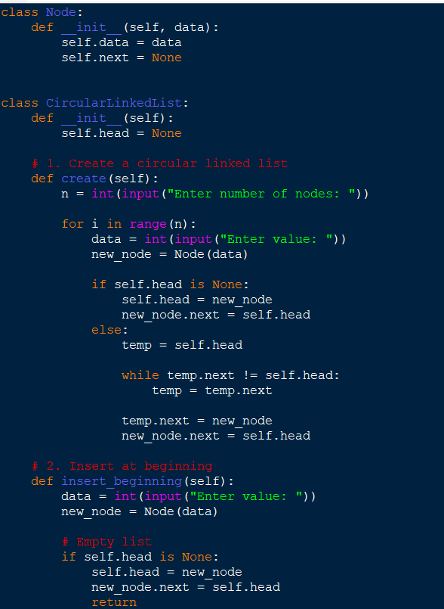

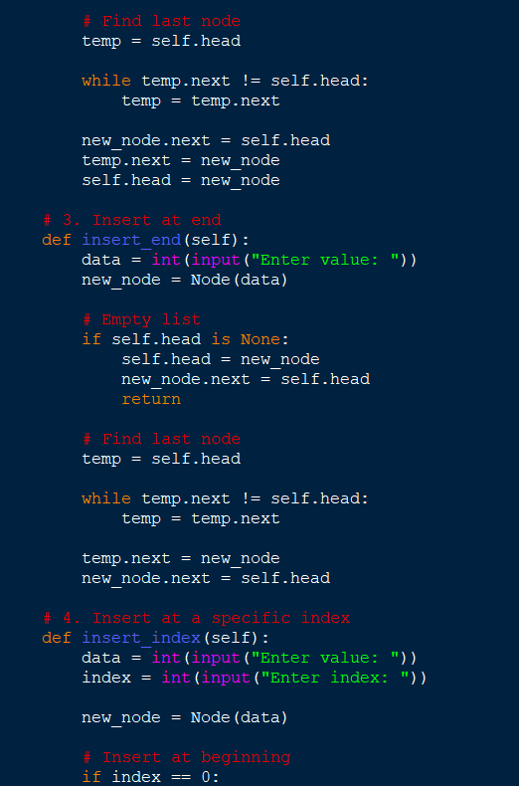
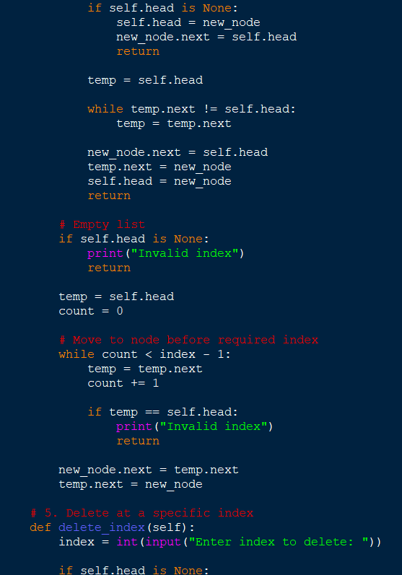
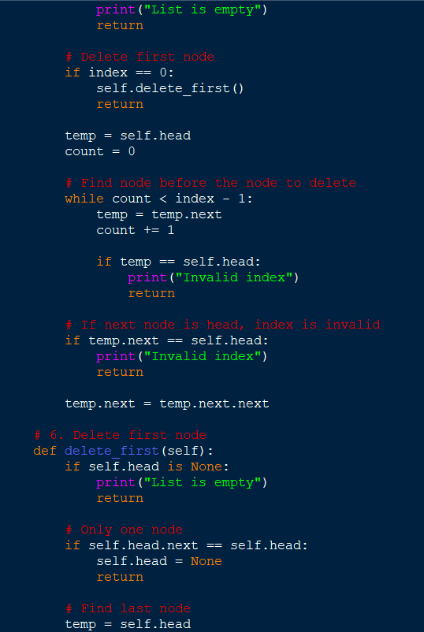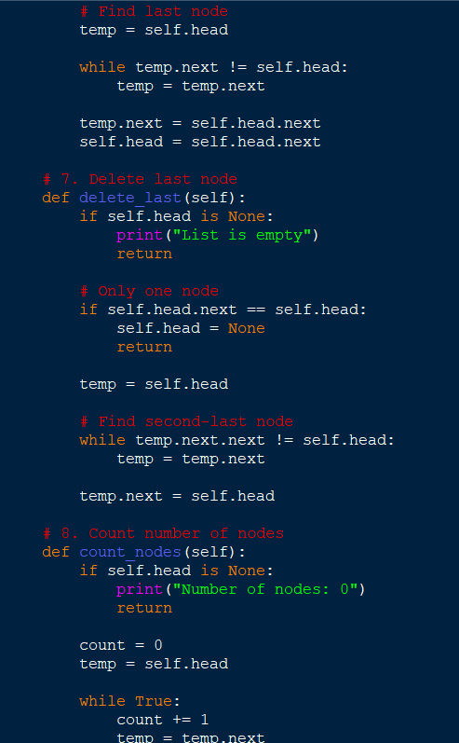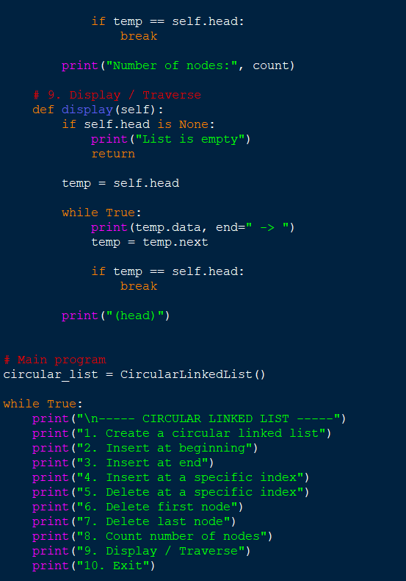
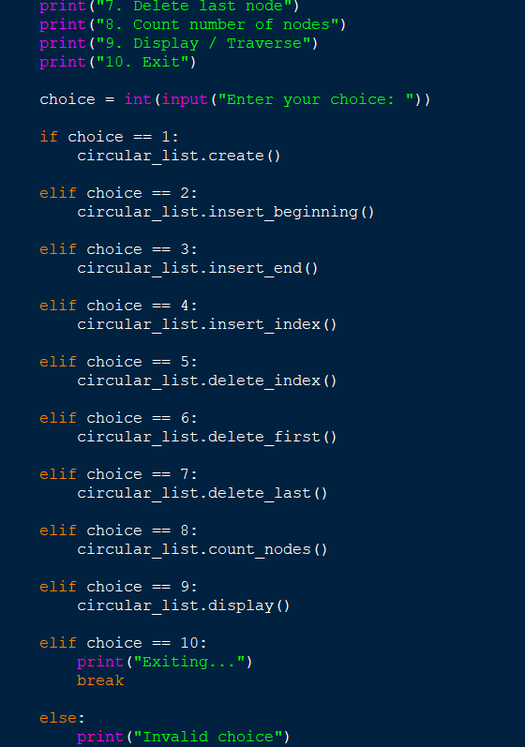
Output:
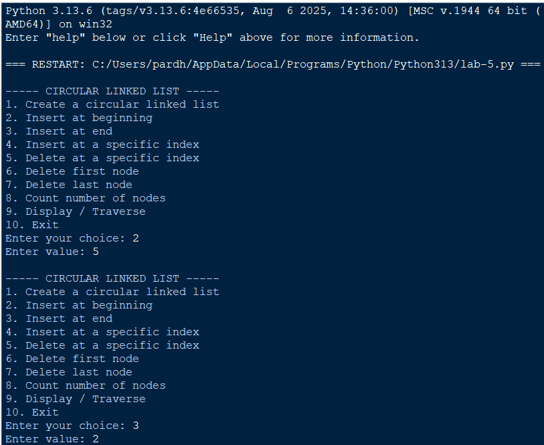

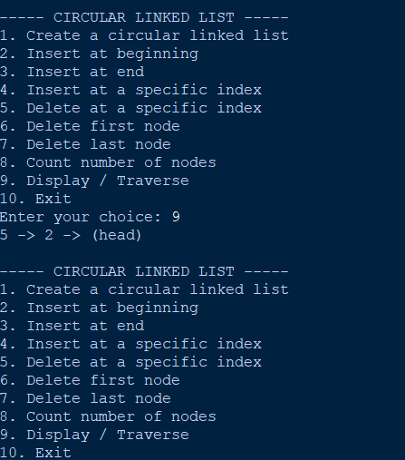

Circular Linked List — Code Explanation
- Node class creates each node with data and a next pointer.
- CircularLinkedList class maintains the list using a head pointer.
- In a circular list, the last node always points back to head, instead of None.
- create() creates nodes and connects the final node back to head.
- insert_beginning() adds a node before head and updates the last node to point to the new head.
- insert_end() finds the last node, adds the new node, and makes it point to head.
- insert_index() traverses to the required position and connects the new node into the circular chain.
- delete_index(), delete_first(), and delete_last() remove nodes while maintaining the circular connection.
- count_nodes() counts nodes until traversal reaches head again.
- display() prints nodes until it reaches head again, preventing an infinite loop.
Errors Encountered:

S.No | Error Observed | Rectification
1 | First node does not point back to head. | Set new_node.next = self.head when creating the first node.
2 | while temp is not None is used to find the last node. | Use while temp.next != self.head:.
3 | Circular traversal causes an infinite loop. | Stop traversal when temp == self.head again.
4 | delete_first() does not update the last node. | Set the last node's next to the new head.
5 | Single-node circular list is not handled during deletion. | Check self.head.next == self.head and set self.head = None.

WEEK-5
1. 5A. Write a Python program to implement a stack using an array and a linked list. Implement the following operations:
- Push
- Pop
- Peek
- Display the stack elements
Code:
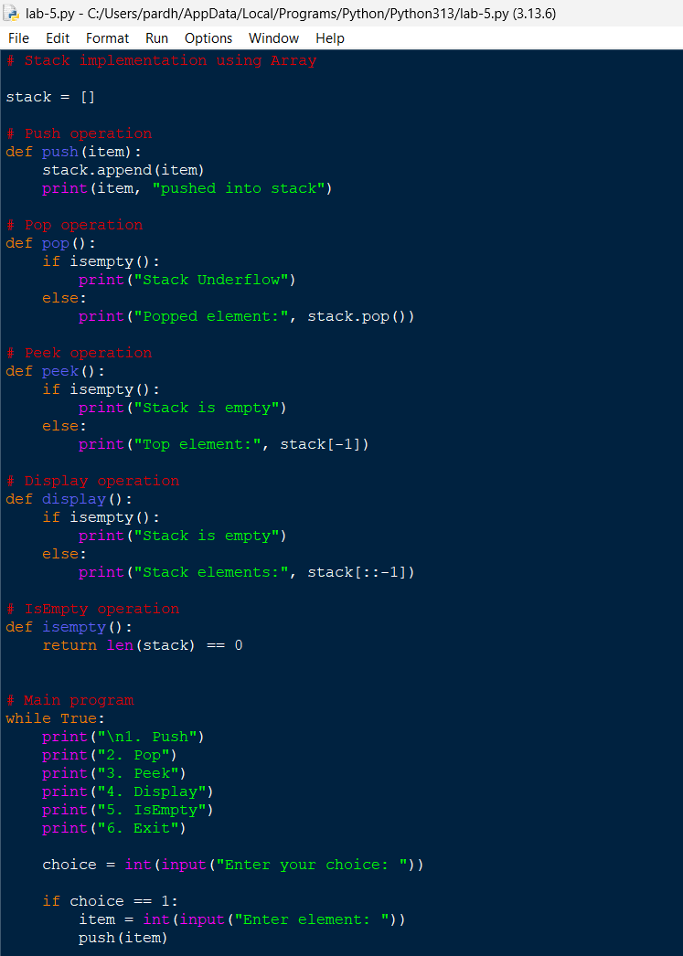
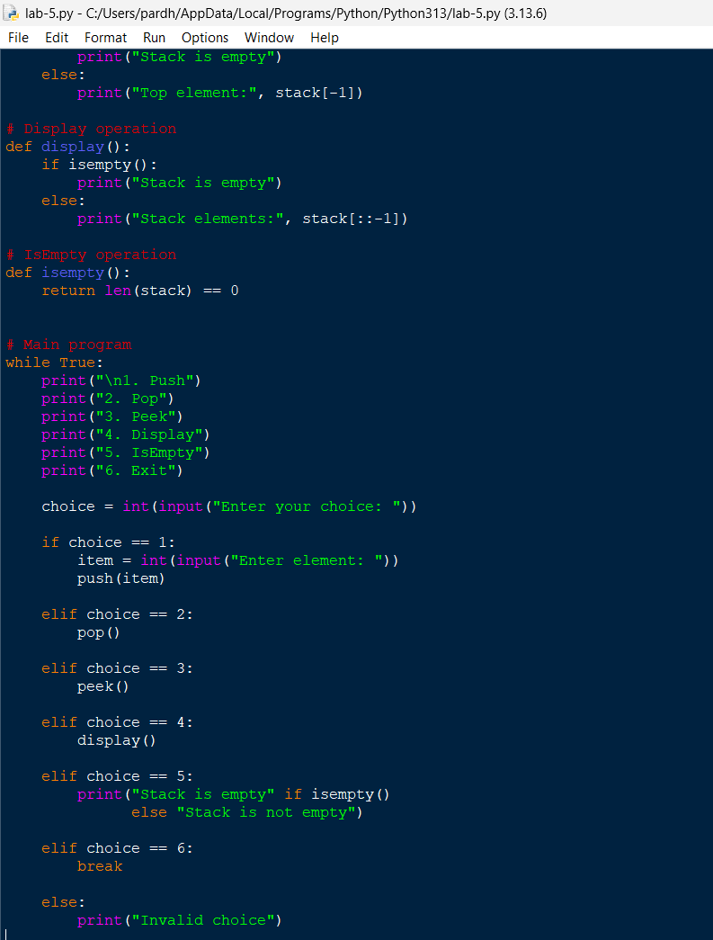
Output: 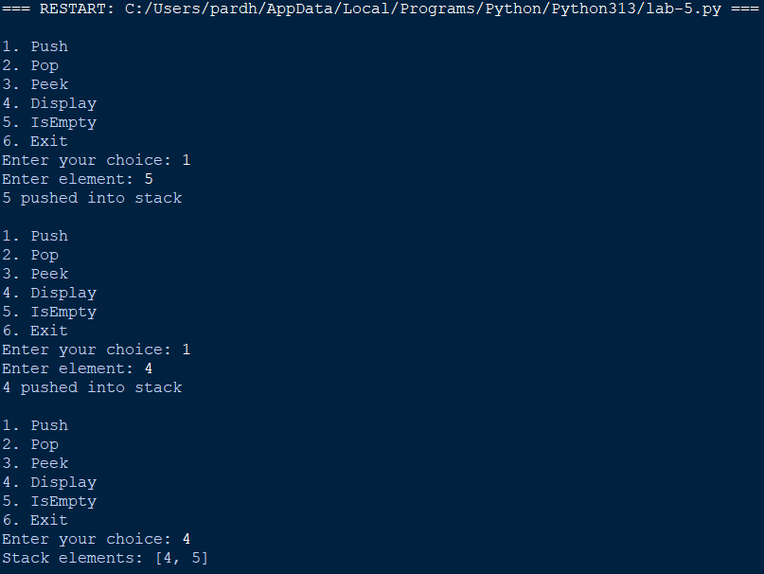
Code Explanation
- A Python list is used to implement the stack.
- push() inserts an element using the append() method.
- pop() removes the topmost element using the pop() method.
- peek() displays the topmost element without removing it.
- display() prints all stack elements from top to bottom.
- isempty() checks whether the stack contains any element
Using Linked list:
Code:
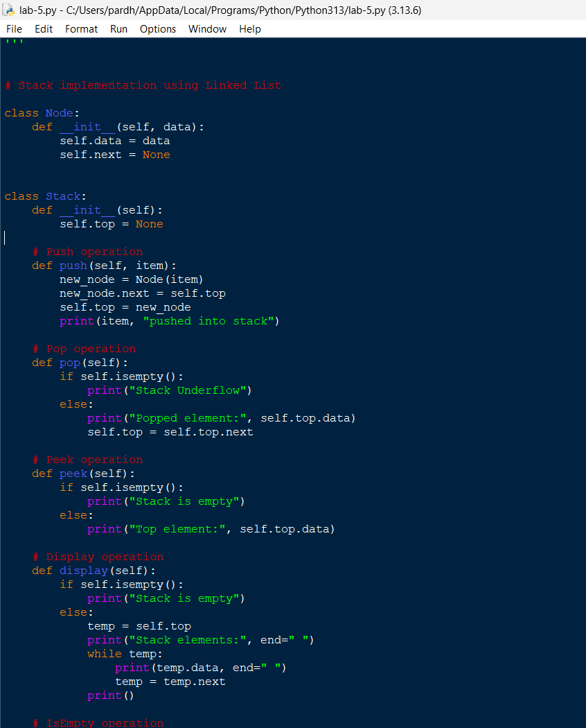
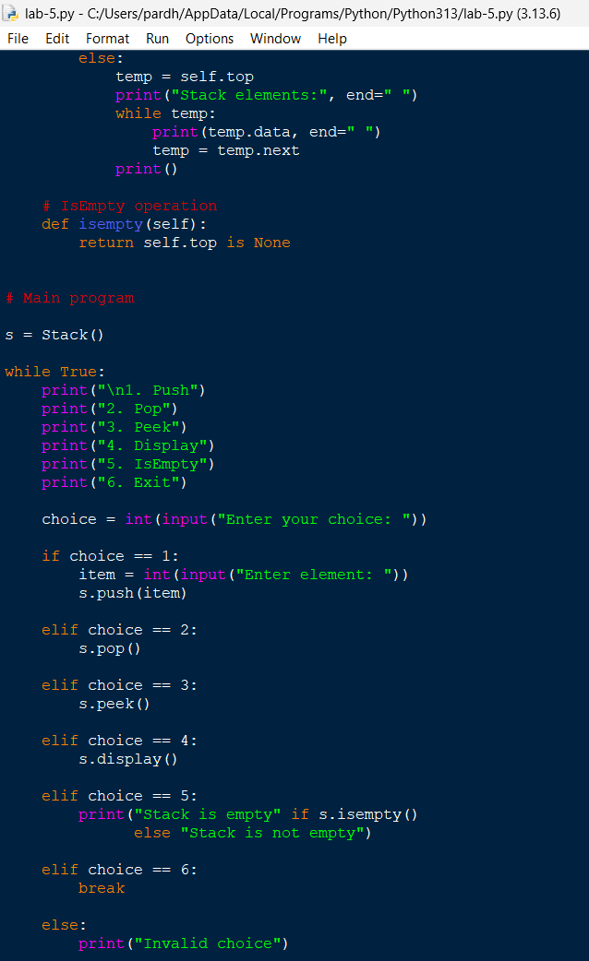

Output: 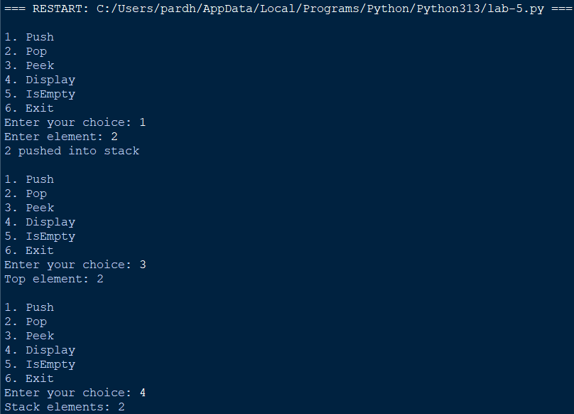

Code Explanation
- A Node class is created with data and a next pointer.
- The Stack class maintains a top pointer to the first node.
- push() creates a new node and inserts it at the beginning.
- pop() removes the top node by updating the top pointer.
- peek() displays the data stored in the top node.
- display() traverses the linked list, and isempty() checks whether the top pointer is None.

S.No | Error Occurred | Rectification
1 | Stack Underflow while performing pop on an empty stack. | Checked whether the stack was empty before performing the pop operation.
2 | Incorrect top element displayed during peek operation. | Used stack[-1] for arrays and top.data for linked lists.
3 | Incorrect pointer updation during push operation. | Correctly updated the new node's next pointer before updating the top pointer.
4 | Elements displayed in the wrong order. | Displayed array elements in reverse order and traversed the linked list from top to bottom.
5 | Attribute error while accessing linked list nodes. | Corrected node references and used self.data and self.next.
6 | Program terminated after executing one operation. | Used a while loop to repeatedly perform operations until the user selects Exit.

WEEK-6
1. 6A. Write a Python program to implement a queue using an array, a linked list, and a circular queue. Implement the following operations:
- Enqueue
- Dequeue
- Peek
- Display the queue elements
Code:
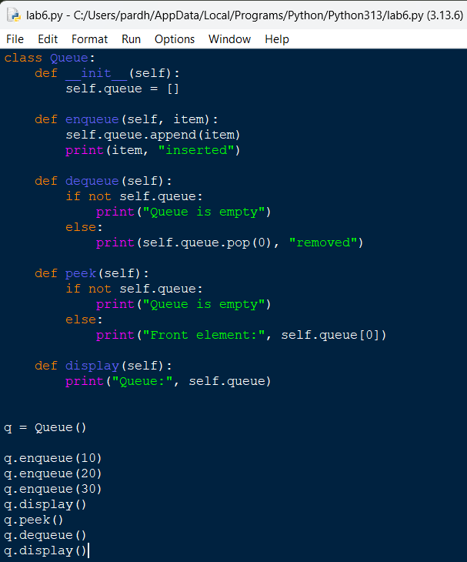

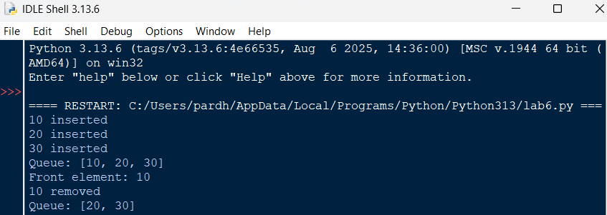
Code Explanation
- A Python list is used to implement the queue.
- The enqueue() function inserts an element at the rear using append().
- The dequeue() function removes the front element using pop(0).
- The peek() function displays the first element without removing it.
- The display() function prints all elements present in the queue.
- Empty queue conditions are checked before performing deletion or peek operations.

Errors Encountered
S.No | Error Occurred | How I Overcame
1 | Dequeue operation on an empty queue. | Added a condition to check whether the list is empty.
2 | Incorrect element removal from the queue. | Used pop(0) to remove the front element.
3 | Index error while accessing the front element. | Checked whether the queue was empty before accessing it.

Using Circular Queue:
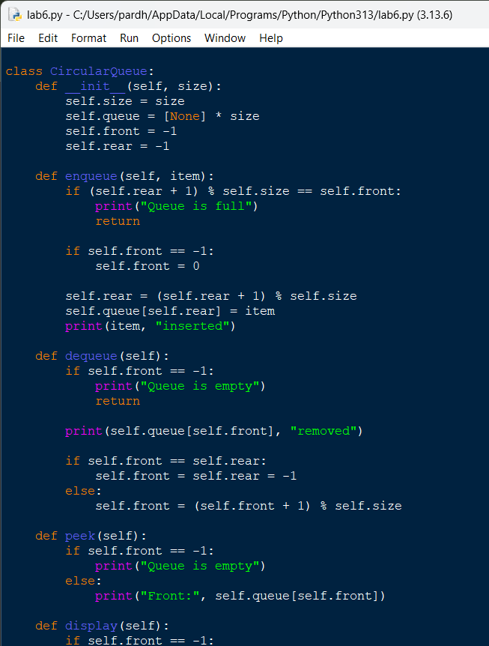
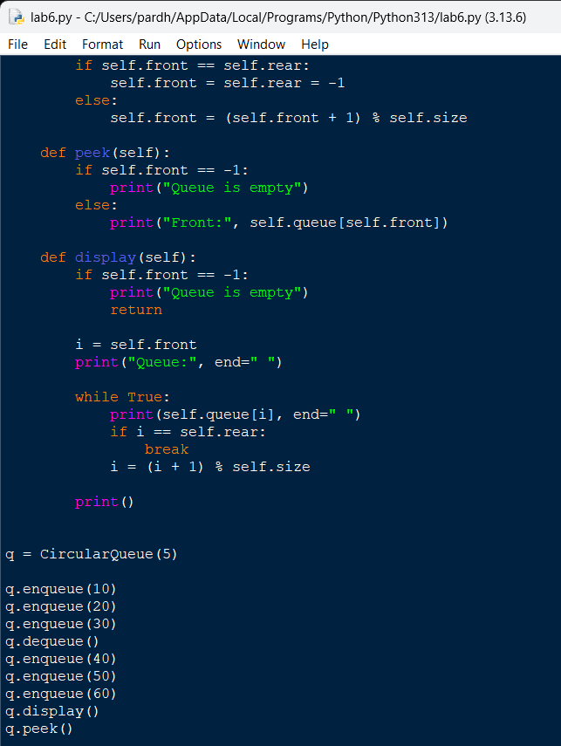
Output:
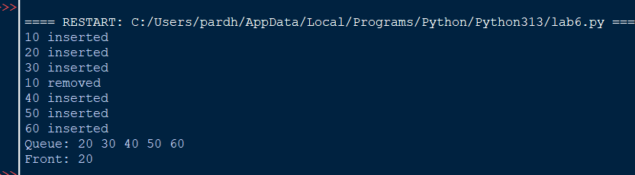

Code Explanation
- A fixed-size array is created to store queue elements.
- Two variables, front and rear, are initialized to -1.
- The enqueue() function inserts elements using the modulo (%) operator.
- The dequeue() function removes the front element and updates the front pointer.
- The peek() function displays the front element without deleting it.
- The display() function traverses the circular queue from front to rear.
- The modulo operator allows the rear pointer to return to index zero when it reaches the last position.

Errors Encountered
S.No | Error Occurred | How I Overcame
1 | Queue overflow during insertion. | Checked whether the next rear position was equal to front.
2 | Incorrect circular indexing. | Used modulo operation for index movement.
3 | Incorrect output after deletion. | Updated the front pointer after removing an element.
4 | Empty queue was not handled properly. | Added underflow checking before dequeue and peek.

Queue using LinkedList:
Code:

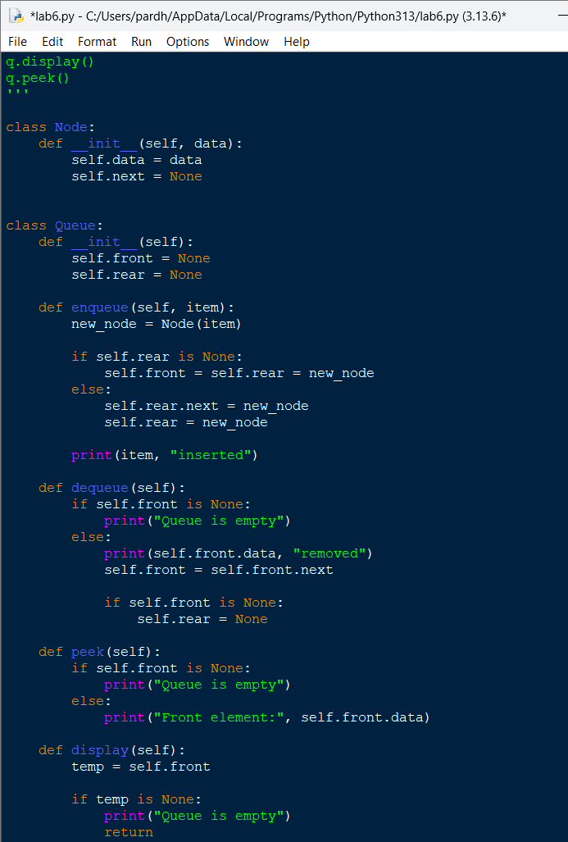

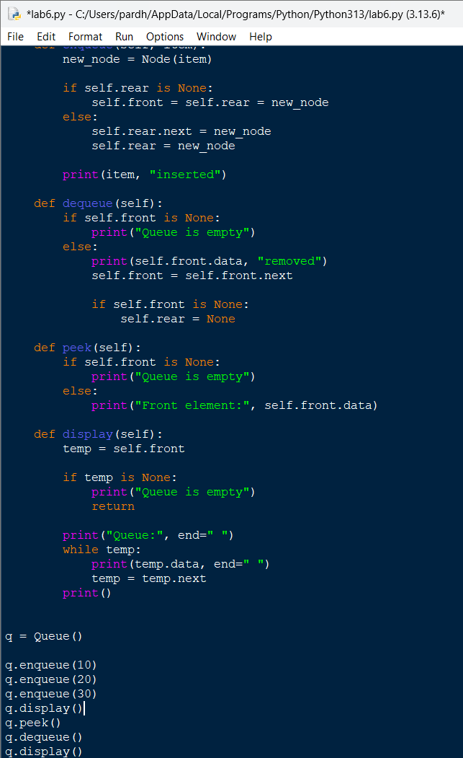
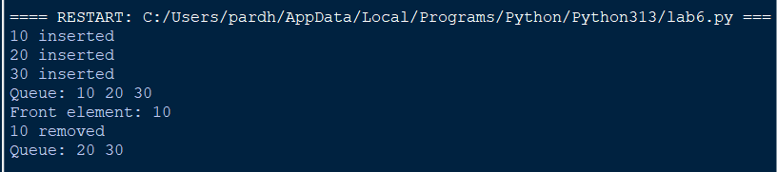

Code Explanation
- A Node class is created to store data and the address of the next node.
- The queue maintains two pointers: front and rear.
- The enqueue() function inserts a new node at the rear.
- The dequeue() function removes the front node and updates the front pointer.
- The peek() function displays the data stored in the front node.
- The display() function traverses the linked list and prints all queue elements.
- When the queue becomes empty, both front and rear pointers are reset.
Errors Encountered
S.No | Error Occurred | How I Overcame
1 | New node was not inserted correctly. | Updated the rear pointer and linked the new node.
2 | Front pointer became invalid after deletion. | Updated the front pointer to the next node.
3 | Rear pointer was not reset when the queue became empty. | Set both front and rear to None.
4 | Display operation failed for an empty queue. | Added an empty queue condition before traversal.

WEEK-7
Aim: Write a Python program to implement a Binary Search Tree using an array and a linked list, performing insertion, deletion, searching, and tree traversals.
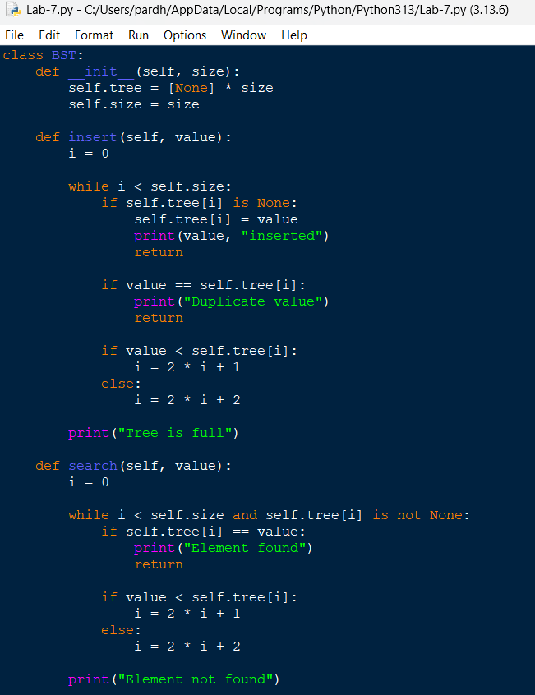
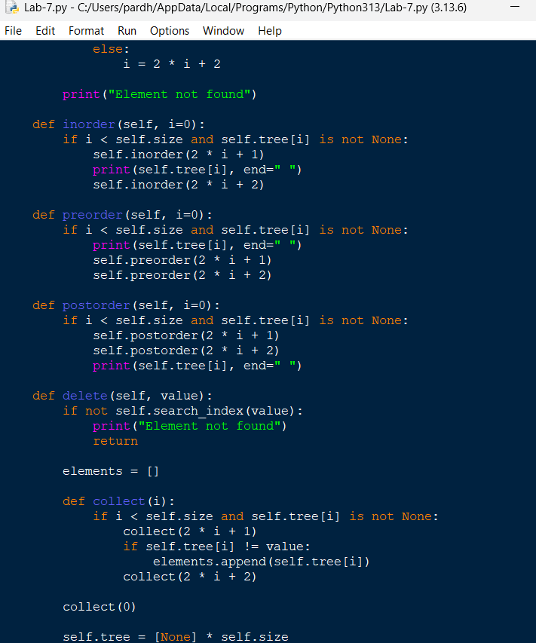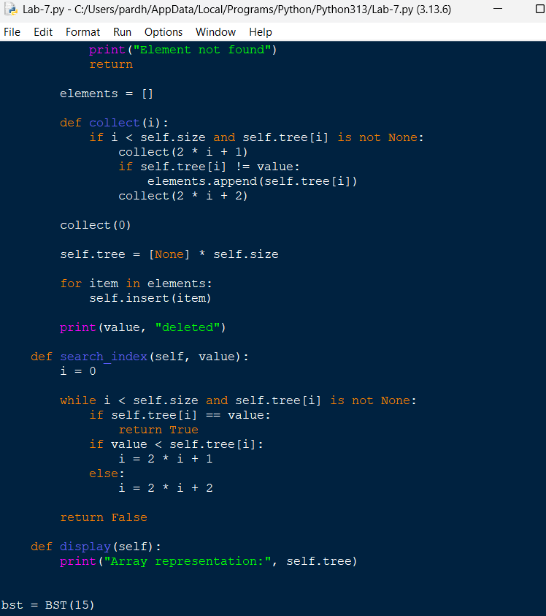
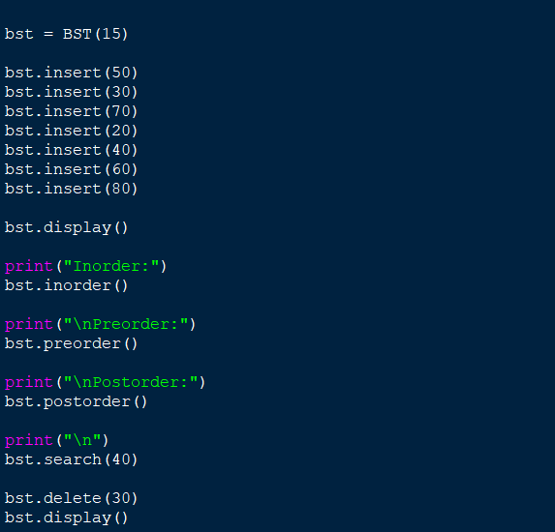
Code Explanation
- An array of fixed size is initialized to store BST elements.
- The insert() function places elements according to BST ordering rules using array indices.
- The search() function compares the target value with each node and moves left or right.
- The delete() function removes the selected element and rebuilds the tree using the remaining elements.
- The inorder() function displays elements in ascending order.
- The preorder() function visits the root, left subtree, and right subtree.
- The postorder() function visits the left subtree, right subtree, and root.
- The display() function prints the array representation of the BST.
Errors Encountered
S.No | Error Occurred | How I Overcame
1 | Array index went out of range during insertion. | Checked the index against the array size.
2 | Incorrect left and right child positions. | Used 2*i+1 and 2*i+2.
3 | Duplicate elements were inserted. | Added a duplicate value checking condition.
4 | Search failed for elements that were not present. | Added a condition to display element not found.
5 | Tree structure changed after deletion. | Rebuilt the tree using the remaining elements.

Using Linked List:
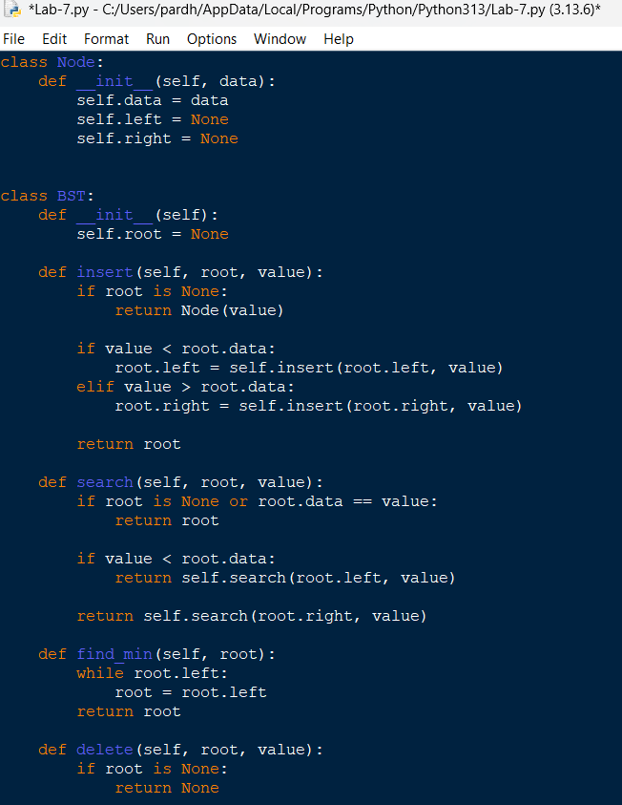
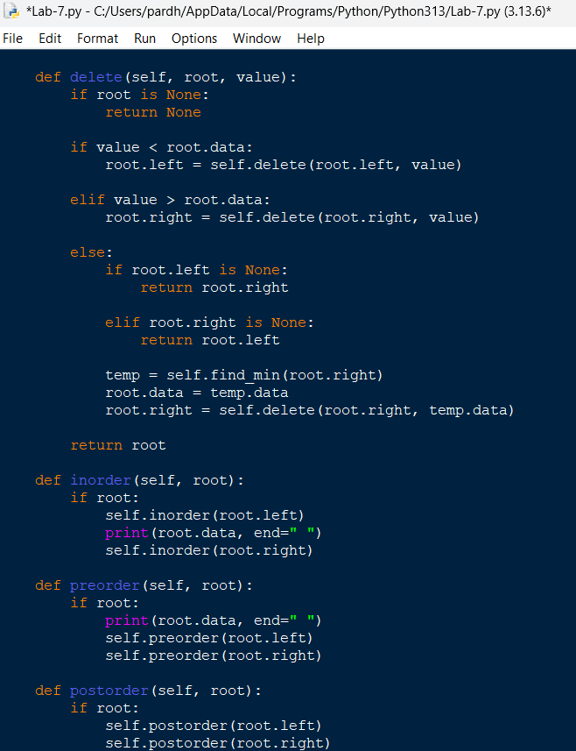
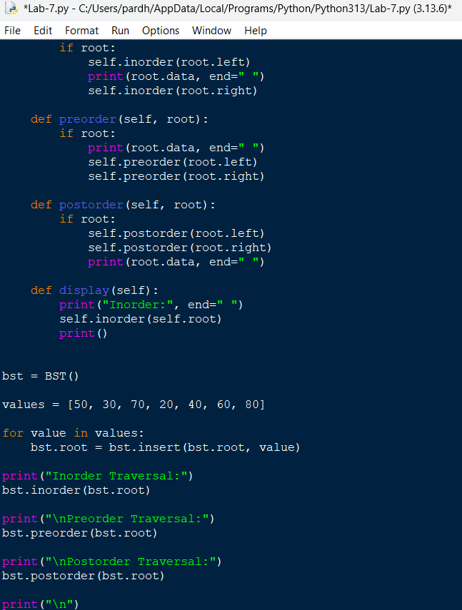
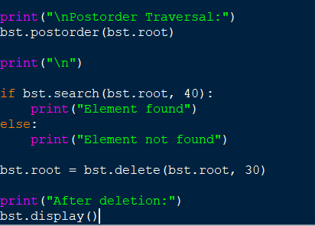

Output:
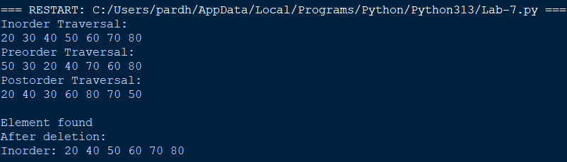
Code Explanation
1.The insert() function creates nodes and places them according to BST properties.
- The search() function recursively searches for the required element.
- The find_min() function finds the smallest element in the right subtree.
- The delete() function handles three cases: leaf node, node with one child, and node with two children.
- The inorder() function displays elements in ascending order.
- The preorder() function visits the root before its subtrees.
- The postorder() function visits the root after its subtrees.
- The display() function displays the BST using inorder traversal.
Errors Encountered
S.No | Error Occurred | How I Overcame
1 | Root node was not initialized correctly. | Initialized the root as None.
2 | Nodes were inserted into the wrong subtree. | Used comparison conditions to select left or right.
3 | Search returned incorrect results. | Added recursive search conditions.
4 | Deletion failed for nodes having two children. | Replaced the node with its inorder successor.
5 | Parent links were not updated after deletion. | Assigned the returned subtree root to the left or right pointer.
WEEK-8
Aim: Write a Python program to implement a Binary Tree using an array and a linked list, performing insertion, deletion, searching, and tree traversal operations.

Code:
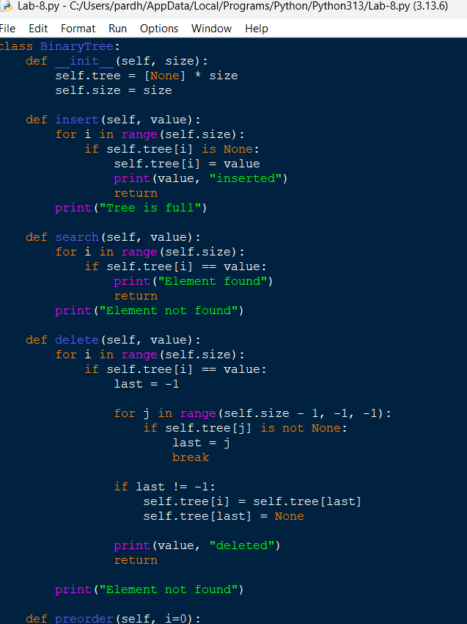
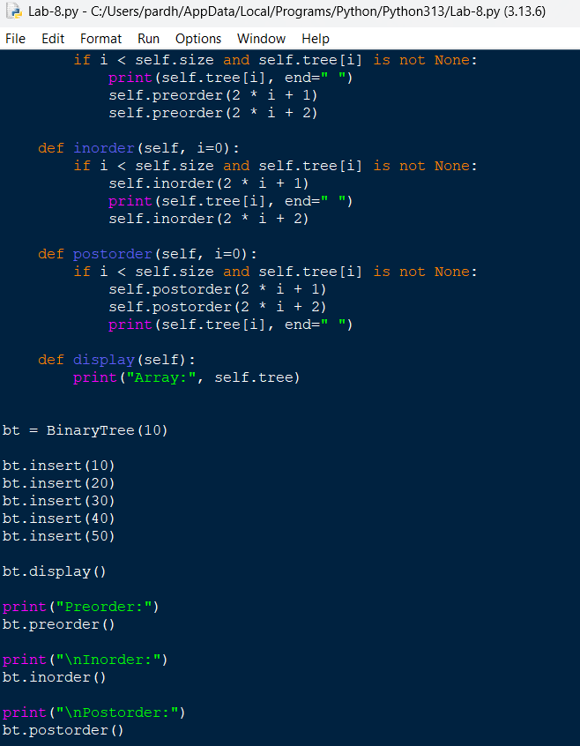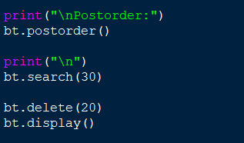

Output:
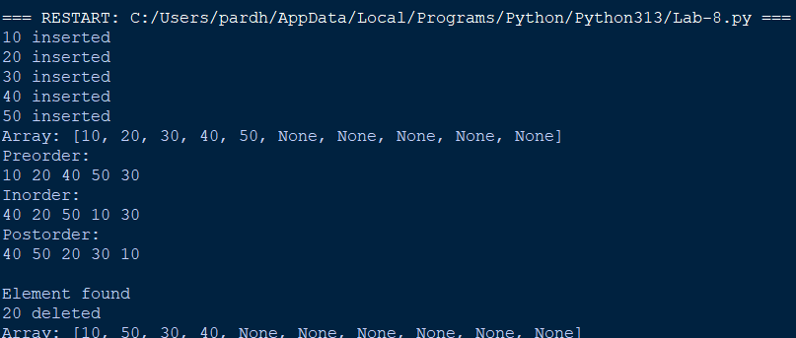
Code Explanation
- A fixed-size array is initialized to store the binary tree elements.
- The insert() function inserts elements into the first available empty position.
- The search() function searches for a particular element by checking each array position.
- The delete() function replaces the deleted element with the last occupied element and removes the last element.
- The preorder() function visits the root, left subtree, and right subtree.
- The inorder() function visits the left subtree, root, and right subtree.
- The postorder() function visits the left subtree, right subtree, and root.
- The display() function displays the array representation of the binary tree.
Errors Encountered
S.No | Error Occurred | How I Overcame
1 | Insertion failed when the array was full. | Added a condition to check the available array positions.
2 | Incorrect child positions during traversal. | Used 2*i+1 and 2*i+2 formulas.
3 | Search failed for missing elements. | Added a condition to display element not found.
4 | Deletion caused incorrect array values. | Replaced the deleted element with the last occupied element.
5 | Traversal accessed empty positions. | Checked whether the node was None before traversal.

Using Linked List:
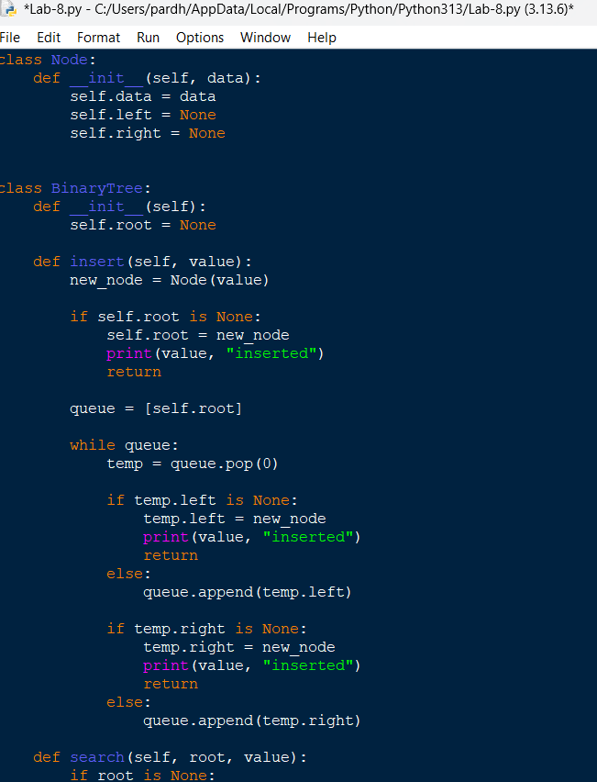
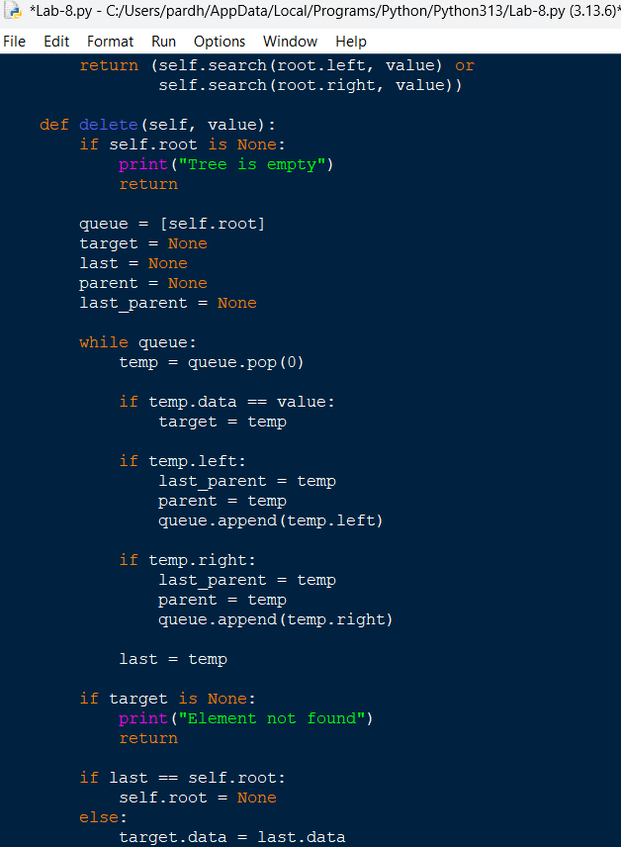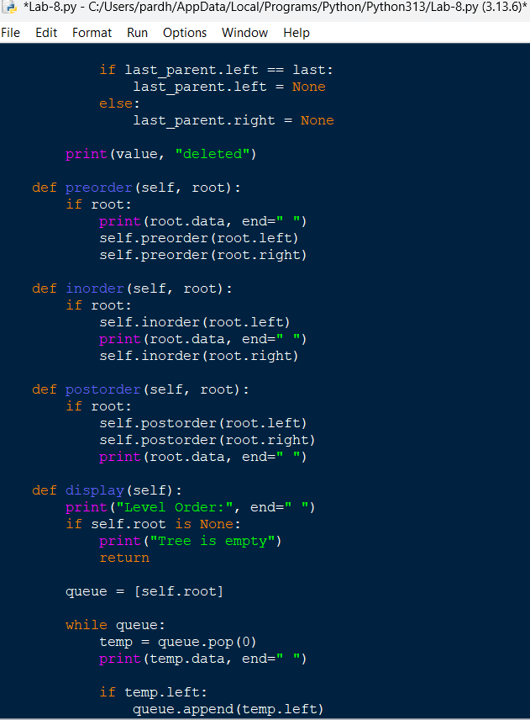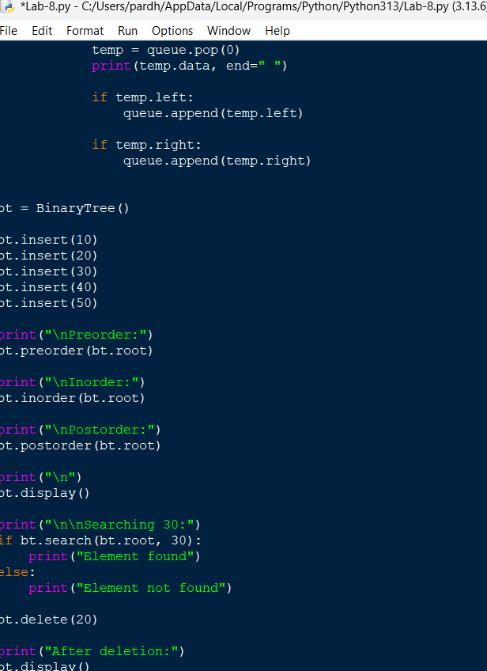
Output:
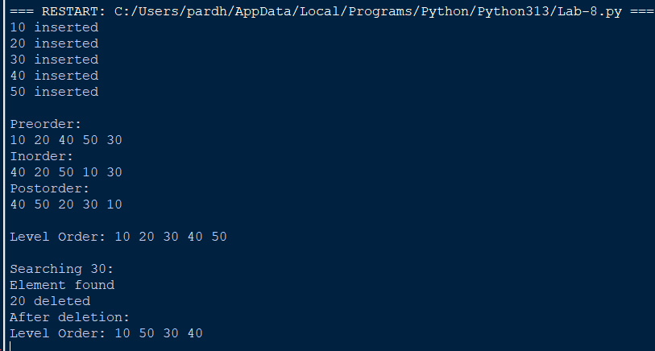
Code Explanation
- A Node class is created with data, left pointer, and right pointer.
- The insert() function inserts new nodes using level-order traversal.
- The search() function recursively searches the left and right subtrees for the given element.
- The delete() function finds the required node and replaces its value with the deepest rightmost node's value.
- The preorder() function visits the root, left subtree, and right subtree.
- The inorder() function visits the left subtree, root, and right subtree.
- The postorder() function visits the left subtree, right subtree, and root.
- The display() function displays the elements using level-order traversal.
Errors Encountered
S.No | Error Occurred | How I Overcame
1 | Root node was not initialized properly. | Initialized the root as None.
2 | Nodes were not inserted in the correct level order. | Used a queue to find the first available position.
3 | Search failed when the tree was empty. | Added a None condition before searching.
4 | Deletion did not maintain the binary tree structure. | Replaced the target node with the deepest rightmost node.
5 | Incorrect traversal output. | Corrected the recursive order of left, root, and right operations.

WEEK-9
Aim: Write Python programs to implement an AVL Tree using an array and a linked list, performing insertion, deletion, searching, and tree traversal operations.
Code:
class AVLTree:
def __init__(self, size=100):
self.nodes = [None] * size
self.root = None
self.size = size

def height(self, i):
if i is None:
return 0
return self.nodes[i]["height"]

def balance(self, i):
if i is None:
return 0

node = self.nodes[i]
return self.height(node["left"]) - self.height(node["right"])

def update_height(self, i):
node = self.nodes[i]
node["height"] = 1 + max(
self.height(node["left"]),
self.height(node["right"])
)

def allocate(self, value):
for i in range(self.size):
if self.nodes[i] is None:
self.nodes[i] = {
"data": value,
"left": None,
"right": None,
"height": 1
}
return i

raise OverflowError("Array is full")

def right_rotate(self, y):
x = self.nodes[y]["left"]
t2 = self.nodes[x]["right"]

self.nodes[x]["right"] = y
self.nodes[y]["left"] = t2

self.update_height(y)
self.update_height(x)

return x

def left_rotate(self, x):
y = self.nodes[x]["right"]
t2 = self.nodes[y]["left"]

self.nodes[y]["left"] = x
self.nodes[x]["right"] = t2

self.update_height(x)
self.update_height(y)

return y

def rebalance(self, i):
self.update_height(i)
bf = self.balance(i)

# LL Case
if bf > 1 and self.balance(self.nodes[i]["left"]) >= 0:
return self.right_rotate(i)

# LR Case
if bf > 1 and self.balance(self.nodes[i]["left"]) < 0:
self.nodes[i]["left"] = self.left_rotate(
self.nodes[i]["left"]
)
return self.right_rotate(i)

# RR Case
if bf < -1 and self.balance(self.nodes[i]["right"]) <= 0:
return self.left_rotate(i)

# RL Case
if bf < -1 and self.balance(self.nodes[i]["right"]) > 0:
self.nodes[i]["right"] = self.right_rotate(
self.nodes[i]["right"]
)
return self.left_rotate(i)

return i

def insert_node(self, i, value):
if i is None:
return self.allocate(value)

if value < self.nodes[i]["data"]:
self.nodes[i]["left"] = self.insert_node(
self.nodes[i]["left"], value
)

elif value > self.nodes[i]["data"]:
self.nodes[i]["right"] = self.insert_node(
self.nodes[i]["right"], value
)

else:
print("Duplicate value")
return i

return self.rebalance(i)

def insert(self, value):
self.root = self.insert_node(self.root, value)
print(value, "inserted")

def search(self, i, value):
if i is None:
return False

if self.nodes[i]["data"] == value:
return True

if value < self.nodes[i]["data"]:
return self.search(self.nodes[i]["left"], value)

return self.search(self.nodes[i]["right"], value)

def find_min(self, i):
while self.nodes[i]["left"] is not None:
i = self.nodes[i]["left"]
return i

def delete_node(self, i, value):
if i is None:
return None

if value < self.nodes[i]["data"]:
self.nodes[i]["left"] = self.delete_node(
self.nodes[i]["left"], value
)

elif value > self.nodes[i]["data"]:
self.nodes[i]["right"] = self.delete_node(
self.nodes[i]["right"], value
)

else:
left = self.nodes[i]["left"]
right = self.nodes[i]["right"]

# Zero or one child
if left is None or right is None:
child = left if left is not None else right
self.nodes[i] = None
return child

# Two children
successor = self.find_min(right)
self.nodes[i]["data"] = self.nodes[successor]["data"]

self.nodes[i]["right"] = self.delete_node(
right, self.nodes[successor]["data"]
)

return self.rebalance(i)

def delete(self, value):
if not self.search(self.root, value):
print("Element not found")
return

self.root = self.delete_node(self.root, value)
print(value, "deleted")

def inorder(self, i):
if i is not None:
self.inorder(self.nodes[i]["left"])
print(self.nodes[i]["data"], end=" ")
self.inorder(self.nodes[i]["right"])

def preorder(self, i):
if i is not None:
print(self.nodes[i]["data"], end=" ")
self.preorder(self.nodes[i]["left"])
self.preorder(self.nodes[i]["right"])

def postorder(self, i):
if i is not None:
self.postorder(self.nodes[i]["left"])
self.postorder(self.nodes[i]["right"])
print(self.nodes[i]["data"], end=" ")

def display(self):
print("Array representation:")
for i, node in enumerate(self.nodes):
if node is not None:
print(i, ":", node)

# Main program
avl = AVLTree()

values = [30, 20, 10, 25, 40, 50]

for value in values:
avl.insert(value)

print("\nInorder:")
avl.inorder(avl.root)

print("\nPreorder:")
avl.preorder(avl.root)

print("\nPostorder:")
avl.postorder(avl.root)

print("\n")
if avl.search(avl.root, 25):
print("Element found")
else:
print("Element not found")

avl.delete(20)

print("\nAfter deletion:")
print("Inorder:")
avl.inorder(avl.root)

print("\n")
avl.display()

Output:
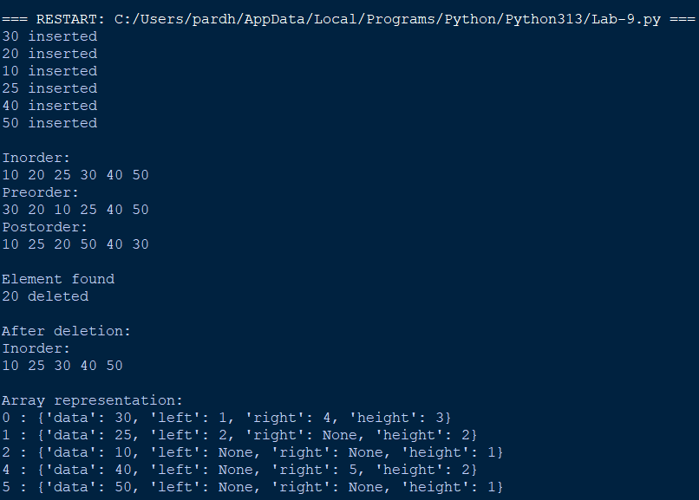

Code Explanation
- An array of fixed size is initialized to store AVL tree nodes.
- Each node stores its data, left child index, right child index, and height.
- The insert() function inserts elements according to BST properties.
- The height() and balance() functions calculate node height and balance factor.
- The left_rotate() and right_rotate() functions perform rotations to maintain AVL balance.
- The rebalance() function identifies LL, RR, LR, and RL cases and performs the required rotations.
- The search() function searches for an element using BST properties.
- The delete() function removes a node and rebalances the tree.
- The inorder(), preorder(), and postorder() functions perform tree traversals.
- The display() function prints the array representation of the AVL tree.

Errors Encountered
S.No | Error Occurred | How I Overcame
1 | Incorrect height calculation. | Updated node height after insertion and rotations.
2 | Balance factor became greater than 1 or less than -1. | Implemented the four AVL rotation cases.
3 | Child indices were not updated after rotation. | Correctly updated left and right child indices.
4 | Array overflow during insertion. | Added a check for available array positions.
5 | Deletion disturbed the AVL balance. | Rebalanced the tree after deleting a node.
6 | Duplicate elements caused incorrect insertion. | Added a duplicate value checking condition.

Using Linked List:
class Node:
def __init__(self, data):

self.data = data
self.left = None
self.right = None
self.height = 1

class AVLTree:

def height(self, root):
if root is None:
return 0
return root.height

def balance(self, root):
if root is None:
return 0

return self.height(root.left) - self.height(root.right)

def right_rotate(self, y):
x = y.left
t2 = x.right

x.right = y
y.left = t2

y.height = 1 + max(
self.height(y.left),
self.height(y.right)
)

x.height = 1 + max(
self.height(x.left),
self.height(x.right)
)

return x

def left_rotate(self, x):
y = x.right
t2 = y.left

y.left = x
x.right = t2

x.height = 1 + max(
self.height(x.left),
self.height(x.right)
)

y.height = 1 + max(
self.height(y.left),
self.height(y.right)
)

return y

def insert(self, root, value):

if root is None:
return Node(value)

if value < root.data:
root.left = self.insert(root.left, value)

elif value > root.data:
root.right = self.insert(root.right, value)

else:
return root

root.height = 1 + max(
self.height(root.left),
self.height(root.right)
)

bf = self.balance(root)

# LL Case
if bf > 1 and value < root.left.data:
return self.right_rotate(root)

# RR Case
if bf < -1 and value > root.right.data:
return self.left_rotate(root)

# LR Case
if bf > 1 and value > root.left.data:
root.left = self.left_rotate(root.left)
return self.right_rotate(root)

# RL Case
if bf < -1 and value < root.right.data:
root.right = self.right_rotate(root.right)
return self.left_rotate(root)

return root

def search(self, root, value):
if root is None or root.data == value:
return root

if value < root.data:
return self.search(root.left, value)

return self.search(root.right, value)

def find_min(self, root):
while root.left is not None:
root = root.left
return root

def delete(self, root, value):

if root is None:
return None

if value < root.data:
root.left = self.delete(root.left, value)

elif value > root.data:
root.right = self.delete(root.right, value)

else:
if root.left is None:
return root.right

elif root.right is None:
return root.left

temp = self.find_min(root.right)
root.data = temp.data
root.right = self.delete(root.right, temp.data)

if root is None:
return None

root.height = 1 + max(
self.height(root.left),
self.height(root.right)
)

bf = self.balance(root)

# LL Case
if bf > 1 and self.balance(root.left) >= 0:
return self.right_rotate(root)

# LR Case
if bf > 1 and self.balance(root.left) < 0:
root.left = self.left_rotate(root.left)
return self.right_rotate(root)

# RR Case
if bf < -1 and self.balance(root.right) <= 0:
return self.left_rotate(root)

# RL Case
if bf < -1 and self.balance(root.right) > 0:
root.right = self.right_rotate(root.right)
return self.left_rotate(root)

return root

def inorder(self, root):
if root:
self.inorder(root.left)
print(root.data, end=" ")
self.inorder(root.right)

def preorder(self, root):
if root:
print(root.data, end=" ")
self.preorder(root.left)
self.preorder(root.right)

def postorder(self, root):
if root:
self.postorder(root.left)
self.postorder(root.right)
print(root.data, end=" ")

def display(self, root):
print("Inorder:", end=" ")
self.inorder(root)
print()

# Main program
avl = AVLTree()
root = None

values = [30, 20, 10, 25, 40, 50]

for value in values:
root = avl.insert(root, value)
print(value, "inserted")

print("\nInorder:")
avl.inorder(root)

print("\nPreorder:")
avl.preorder(root)

print("\nPostorder:")
avl.postorder(root)

print("\n")

if avl.search(root, 25):
print("Element found")
else:
print("Element not found")

root = avl.delete(root, 20)

print("\nAfter deletion:")
avl.display(root)

Output:
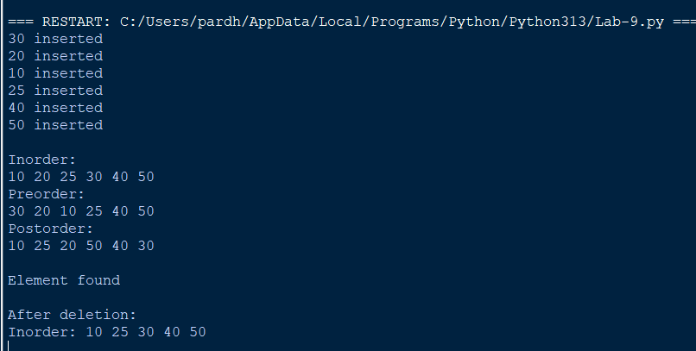

Code Explanation
- A Node class is created to store data, left pointer, right pointer, and height.
- The height() function returns the height of a node.
- The balance() function calculates the balance factor of each node.
- The insert() function inserts elements following BST properties and updates their heights.
- The left_rotate() and right_rotate() functions perform rotations to balance the tree.
- The search() function searches for an element using recursive comparison.
- The find_min() function finds the smallest node in the right subtree.
- The delete() function deletes a node and restores AVL balance using rotations.
- The inorder(), preorder(), and postorder() functions perform tree traversal operations.
- The display() function displays the tree elements using inorder traversal.
Errors Encountered
S.No | Error Occurred | How I Overcame
1 | Node height was not updated correctly. | Recalculated height after every insertion and deletion.
2 | Balance factor became invalid. | Implemented LL, RR, LR, and RL rotations.
3 | Rotation caused incorrect child connections. | Updated left and right pointers carefully.
4 | Search failed for unavailable elements. | Added a None condition to stop recursive searching.
5 | Deletion caused an unbalanced tree. | Updated heights and performed rotations after deletion.
6 | Root pointer was not updated after rotation. | Assigned the returned root after every insertion and deletion.

WEEK-10
Aim: Write Python programs to implement hashing using the following collision resolution techniques:
- Separate Chaining
- Linear Probing
- Quadratic Probing

1.Separate Chaining

class HashTable:
def __init__(self, size):
self.size = size
self.table = [[] for i in range(size)]

def hash_function(self, key):
return key % self.size

def insert(self, key):
index = self.hash_function(key)

if key not in self.table[index]:
self.table[index].append(key)
print(key, "inserted")
else:
print("Duplicate key")

def search(self, key):
index = self.hash_function(key)

if key in self.table[index]:
print("Element found")
else:
print("Element not found")

def delete(self, key):
index = self.hash_function(key)

if key in self.table[index]:
self.table[index].remove(key)
print(key, "deleted")
else:
print("Element not found")

def display(self):
for i in range(self.size):
print(i, ":", self.table[i])

# Main program
ht = HashTable(7)

ht.insert(10)
ht.insert(20)
ht.insert(15)
ht.insert(25)
ht.insert(30)

print("\nHash Table:")
ht.display()

print("\nSearching:")
ht.search(25)

print("\nDeleting:")
ht.delete(20)

print("\nUpdated Hash Table:")
ht.display()

Output:
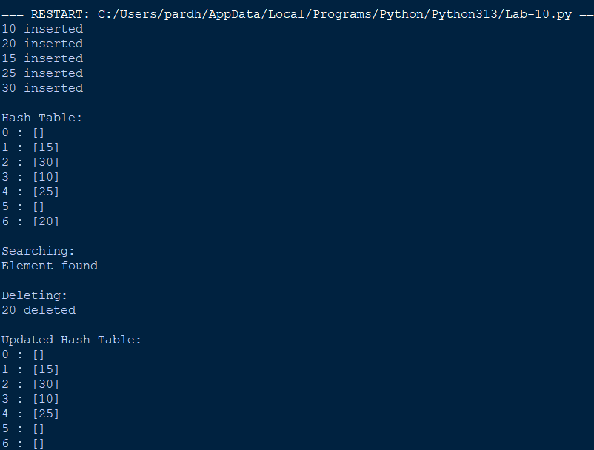

Code Explanation
- A hash table of fixed size is created using a list of empty lists.
- The hash_function() calculates the index using the modulo operator.
- The insert() function stores keys in the corresponding index list.
- If multiple keys generate the same index, they are stored in the same list.
- The search() function checks whether the key exists in the corresponding list.
- The delete() function removes the specified key from its list.
- The display() function displays all indices and their stored elements.

Errors Encountered
S.No | Error Occurred | How I Overcame
1 | Multiple keys generated the same index. | Used separate lists at each hash table index.
2 | Duplicate elements were inserted. | Added a condition to check whether the key already exists.
3 | Search failed for unavailable elements. | Checked whether the key exists in the corresponding list.
4 | Deletion failed for missing elements. | Added an element existence condition before deletion.

2. Hashing using Linear Probing
class HashTable:
def __init__(self, size):
self.size = size
self.table = [None] * size

def hash_function(self, key):
return key % self.size

def insert(self, key):
index = self.hash_function(key)

for i in range(self.size):
new_index = (index + i) % self.size

if self.table[new_index] is None:
self.table[new_index] = key
print(key, "inserted at index", new_index)
return

if self.table[new_index] == key:
print("Duplicate key")
return

print("Hash table is full")

def search(self, key):
index = self.hash_function(key)

for i in range(self.size):
new_index = (index + i) % self.size

if self.table[new_index] is None:
print("Element not found")
return

if self.table[new_index] == key:
print("Element found at index", new_index)
return

print("Element not found")

def delete(self, key):
index = self.hash_function(key)

for i in range(self.size):
new_index = (index + i) % self.size

if self.table[new_index] is None:
print("Element not found")
return

if self.table[new_index] == key:
self.table[new_index] = "DELETED"
print(key, "deleted")
return

print("Element not found")

def display(self):
for i in range(self.size):
print(i, ":", self.table[i])

# Main program
ht = HashTable(7)

ht.insert(10)
ht.insert(20)
ht.insert(15)
ht.insert(25)
ht.insert(30)

print("\nHash Table:")
ht.display()

print("\nSearching:")
ht.search(25)

print("\nDeleting:")
ht.delete(20)

print("\nUpdated Hash Table:")
ht.display()
Output:
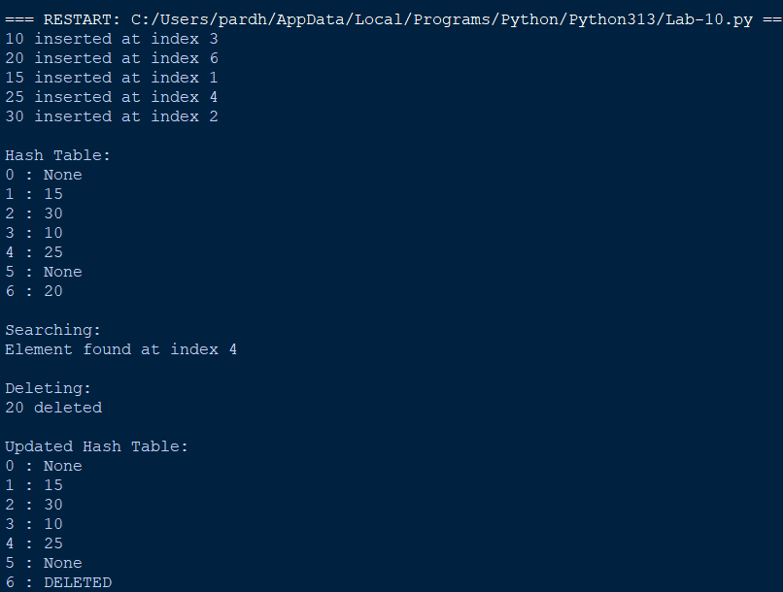
Code Explanation
- A fixed-size hash table is initialized with None values.
- The hash_function() calculates the original index using the modulo operator.
- The insert() function checks the calculated index for an empty position.
- If a collision occurs, linear probing checks the next position using (index+i) % size.
- The search() function checks consecutive positions until the key is found or an unused position is reached.
- The delete() function marks the deleted position as DELETED to preserve the probing sequence.
- The display() function prints the hash table with its indices and values.
Errors Encountered
S.No | Error Occurred | How I Overcame
1 | Collision occurred during insertion. | Checked the next available index using linear probing.
2 | Index went beyond the table size. | Used modulo operation to wrap around the table.
3 | Searching stopped incorrectly after deletion. | Used a DELETED marker instead of None.
4 | Duplicate keys were inserted. | Added duplicate checking before insertion.
5 | Insertion failed when the table was full. | Added a loop to check all available positions.

4.Hashing using Quadratic Probing
class HashTable:
def __init__(self, size):
self.size = size
self.table = [None] * size

def hash_function(self, key):
return key % self.size

def insert(self, key):
index = self.hash_function(key)

for i in range(self.size):
new_index = (index + i * i) % self.size

if self.table[new_index] is None:
self.table[new_index] = key
print(key, "inserted at index", new_index)
return

if self.table[new_index] == key:
print("Duplicate key")
return

print("No available position found")

def search(self, key):
index = self.hash_function(key)

for i in range(self.size):
new_index = (index + i * i) % self.size

if self.table[new_index] is None:
print("Element not found")
return

if self.table[new_index] == key:
print("Element found at index", new_index)
return

print("Element not found")

def delete(self, key):
index = self.hash_function(key)

for i in range(self.size):
new_index = (index + i * i) % self.size

if self.table[new_index] is None:
print("Element not found")
return

if self.table[new_index] == key:
self.table[new_index] = "DELETED"
print(key, "deleted")
return

print("Element not found")

def display(self):
for i in range(self.size):
print(i, ":", self.table[i])

# Main program
ht = HashTable(7)

ht.insert(10)
ht.insert(20)
ht.insert(15)
ht.insert(25)
ht.insert(30)

print("\nHash Table:")
ht.display()

print("\nSearching:")
ht.search(25)

print("\nDeleting:")
ht.delete(20)

print("\nUpdated Hash Table:")
ht.display()

Output:
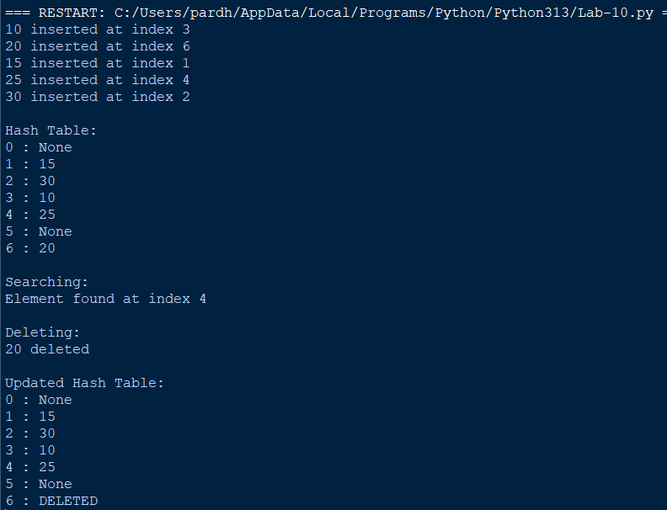

Code Explanation
- A fixed-size hash table is created using a Python list.
- The hash_function() calculates the original index using the modulo operator.
- The insert() function places elements at their calculated positions.
- If a collision occurs, quadratic probing checks positions using (index+i*i) % size.
- The search() function follows the same quadratic probing sequence to find an element.
- The delete() function marks the deleted position as DELETED to maintain the search sequence.
- The display() function displays all indices and their corresponding values.
Errors Encountered
S.No | Error Occurred | How I Overcame
1 | Collision occurred at the original hash index. | Used quadratic probing to find another position.
2 | Incorrect index calculation. | Applied the formula (index+i*i) % size.
3 | Searching failed after deletion. | Used a DELETED marker instead of clearing the position.
4 | Duplicate elements were inserted. | Added a condition to check for existing keys.
5 | An empty position could not be found. | Added a loop limit and displayed an appropriate message.

